**VIVEKANAND EDUCATION SOCIETY’S INSTITUTE OF TECHNOLOGY**

**(An Autonomous Institute Affiliated to University of Mumbai)**

**Department of Computer Engineering**



Project Report on

**Visual Digital Twin of Medical Solutions for a specialised Gen AI Agentic Model**

In partial fulfillment of the Fourth Year, Bachelor of Engineering (B.E.) Degree in Computer Engineering at the University of Mumbai

Academic Year 2024-25

By

**Kinjala Ahuja (D17C, 01)**

**Taufique Ansari (D17C, 04)**

**Devangana Barua (D17C, 06)**

**Dipanshu Ghime (D17C, 18)**

Project Mentor

**Dr. Sharmila Sengupta**

**A.Y. 2024 - 25**

**VIVEKANAND EDUCATION SOCIETY’S INSTITUTE OF TECHNOLOGY**

**(An Autonomous Institute Affiliated to University of Mumbai)**

**Department of Computer Engineering**

**Certificate**

This is to certify that **Kinjala Ahuja - D17C 01, Taufique Ansari - D17C 04, Devangana Barua - D17C 06, Dipanshu Ghime - D17C 18** of Fourth Year Computer Engineering studying under the University of Mumbai have satisfactorily completed the project on “**Visual Digital Twin of Medical Solutions for a specialised Gen AI Agentic Model**” as a part of their coursework of PROJECT-II for Semester-VIII under the guidance of their mentor **Dr. Sharmila Sengupta** in the year 2024-25.

This project report entitled **Visual Digital Twin of Medical Solutions for a specialised Gen AI Agentic Model** by **Kinjala Ahuja, Taufique Ansari, Devangana Barua, Dipanshu Ghime** is approved for the degree of **Bachelor of Engineering** in **Computer Engineering.**

| Programme Outcomes | Grade |
| --- | --- |
| PO1, PO2, PO3, PO4, PO5, PO6, PO7, PO8, PO9, PO10, PO11, PO12  PSO1 & PSO2 |  |

**Date:** 28th April, 2025

**Project Guide:**  Dr. Sharmila Sengupta

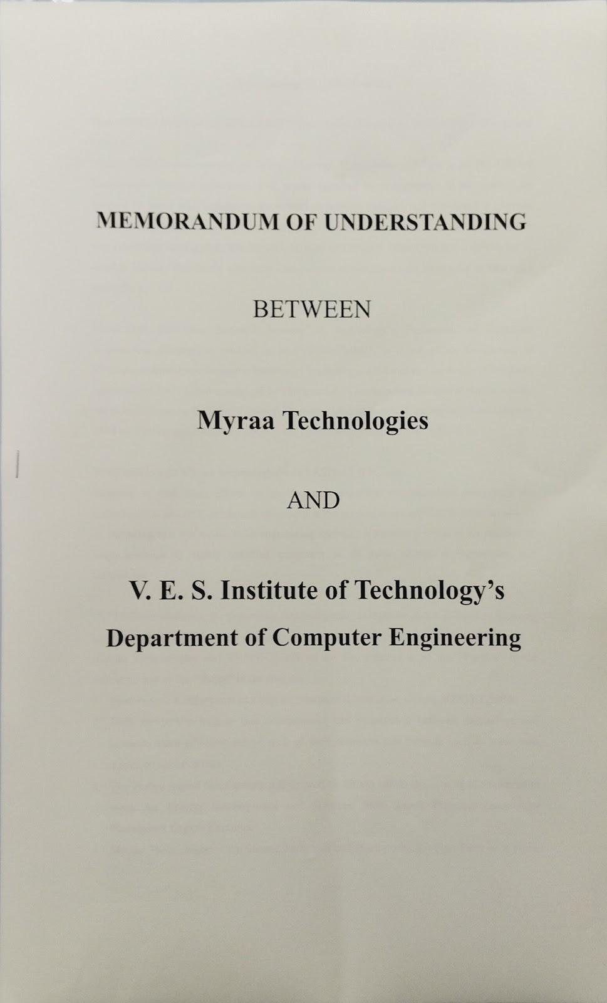

# Project Report Approval

# For

# B. E (Computer Engineering)

This project report entitled “**Visual Digital Twin of Medical Solutions for a specialised Gen AI Agentic Model”**  by **Kinjala Ahuja D17C 01, Taufique Ansari D17C 04, Devangana Barua D17C 06, Dipanshu Ghime D17C 18** is approved for the degree of **Bachelor of Engineering in Computer Engineering.**

**Examiners**

**1. ………………………………**

(Internal Examiner name & sign)

**2. ………………………………**

(External Examiner name & sign)

**3. ………………………………**

(Head of Department)

**4. ………………………………**

(Principal)

**Date:** 28th April, 2025

**Place:** Chembur, Mumbai

# Declaration

We declare that this written submission represents our ideas in our own words and where others' ideas or words have been included, we have adequately cited and referenced the original sources. We also declare that we have adhered to all principles of academic honesty and integrity and have not misrepresented or fabricated or falsified any idea / data / fact / source in our submission. We understand that any violation of the above will be cause for disciplinary action by the Institute and can also evoke penal action from the sources which have thus not been properly cited or from whom proper permission has not been taken when needed.

| -----------------------------------------  ( Kinjala Ahuja D17C 01 ) | -----------------------------------------  ( Taufique Ansari D17C 04 ) |
| --- | --- |
| -----------------------------------------  ( Devangana Barua D17C 06 ) | -----------------------------------------  ( Dipanshu Ghime D17C 18 ) |

**Date:** 28th April, 2025

**ACKNOWLEDGEMENT**

We are thankful to our college Vivekanand Education Society’s Institute of Technology for considering our project and extending help at all stages needed during our work of collecting information regarding the project.

It gives us immense pleasure to express our deep and sincere gratitude to **Dr. Sharmila Sengupta** for her kind help and valuable advice during the development of project synopsis and for her guidance and suggestions.

We are deeply indebted to Head of the Computer Department **Dr.(Mrs.) Nupur Giri** and our Principal **Dr. (Mrs.) J.M. Nair ,** for giving us this valuable opportunity to do this project.

We express our hearty thanks to them for their assistance without which it would have been difficult in finishing this project synopsis and project review successfully.

We convey our deep sense of gratitude to all teaching and non-teaching staff for their constant encouragement, support and selfless help throughout the project work. It is great pleasure to acknowledge the help and suggestion, which we received from the Department of Computer Engineering.

We wish to express our profound thanks to all those who helped us in gathering information about the project. Our families too have provided moral support and encouragement several times.

## Computer Engineering Department

### COURSE OUTCOMES FOR B.E. PROJECT

#### Learners will be able to,

| **Course Outcome** | **Description of the Course Outcome** |
| --- | --- |
| CO1 | Able to apply the relevant engineering concepts, knowledge and skills towards the project. |
| CO2 | Able to identify, formulate and interpret the various relevant research papers and to determine the problem. |
| CO3 | Able to apply the engineering concepts towards designing solutions for the problem. |
| CO4 | Able to interpret the data and datasets to be utilized. |
| CO5 | Able to create, select and apply appropriate technologies, techniques, resources and tools for the project. |
| CO6 | Able to apply ethical, professional policies and principles towards societal, environmental, safety and cultural benefit. |
| CO7 | Able to function effectively as an individual, and as a member of a team, allocating roles with clear lines of responsibility and accountability. |
| CO8 | Able to write effective reports, design documents and make effective presentations. |
| CO9 | Able to apply engineering and management principles to the project as a team member. |
| CO10 | Able to apply the project domain knowledge to sharpen one’s competency. |
| CO11 | Able to develop a professional, presentational, balanced and structured approach towards project development. |
| CO12 | Able to adopt skills, languages, environment and platforms for creating innovative solutions for the project. |

**Index**

| **Chapter No.** | **Title of Contents** | **Page no.** |
| --- | --- | --- |
|  | **Abstract** | 1 |
| **1** | **Introduction** | 2 |
| 1.1 | Introduction to the Project | 2 |
| 1.2 | Motivation of our Project | 2 |
| 1.3 | Problem Definition | 2 |
| 1.4 | Existing Systems | 3 |
| 1.5 | Lacuna of the existing systems | 3 |
| 1.6 | Relevance of the Project | 4 |
| **2** | **Literature Survey** | **5** |
| A | Brief Overview of Literature Survey | **5** |
| B | Related Works | **5** |
| 2.1 | Research Papers Referred | 6 |
| 2.2 | Patent search | 7 |
| 2.3 | Inference drawn | 8 |
| 2.4 | Comparison with the existing system | 9 |
| **3** | **Requirement Gathering for the Proposed System** | 10 |
| 3.1 | Introduction to requirement gathering | 10 |
| 3.2 | Functional Requirements | 10 |
| 3.3 | Non-Functional Requirements | 11 |
| 3.4 | Hardware, Software, Technology and tools utilized | 12 |
| 3.5 | Constraints | 13 |
| **4** | **Proposed Design** | 14 |
| 4.1 | Block diagram of the system | 14 |
| 4.2 | Modular design of the system | 14 |
| 4.3 | Detailed Design | 15 |
| 4.4 | Gantt Chart | 16 |

| **5** | **Implementation of the Proposed System** | 17 |
| --- | --- | --- |
| 5.1 | Methodology employed for development | 17 |
| 5.2 | Algorithms and flowcharts for the respective modules developed | 18 |
| 5.3 | Datasets source and utilization | 20 |
| **6** | **Testing of the Proposed System** | 21 |
| 6.1 | Introduction to testing | 21 |
| 6.2 | Types of tests considered | 21 |
| 6.3 | Various test case scenarios considered | 23 |
| 6.4 | Inference drawn from the test cases | 24 |
| **7** | **Results and Discussion** | 25 |
| 7.1 | Screenshots of User Interface (UI) for the respective module | 25 |
| 7.2 | Performance Evaluation measures | 31 |
| 7.3 | Input & Output Parameters | 32 |
| 7.4 | Graphical and statistical output | 34 |
| 7.5 | Comparison of results with existing systems | 34 |
| 7.6 | Inference drawn | 35 |
| **8** | **Conclusion** | 36 |
| 8.1 | Limitations | 36 |
| 8.2 | Conclusion | 36 |
| 8.3 | Future Scope | 37 |
|  | **References** | 38 |
|  | **Appendix** | 40 |
| 1 | NDA | 40 |
| 2 | Project Review Sheets | 42 |

**List of Tables :**

| **Table No.** | **Heading** | **Page No.** |
| --- | --- | --- |
| 2.1 | Comparison With Existing System | 9 |
| 6.1 | User Login Test Case | 23 |
| 6.2 | Admin Device Management Test Case | 23 |
| 6.3 | Image Generation Test Case | 24 |
| 6.4 | Error Handling Test Case | 24 |
| 7.1 | Results of our Model | 34 |
| 7.2 | Comparison of Results with Existing Systems | 34 |

**List of Figures :**

| **Fig No.** | **Heading** | **Page No.** |
| --- | --- | --- |
| 4.1 | Block Diagram of the System | 14 |
| 4.2 | Modular Design of System | 14 |
| 4.3 | Detailed Design | 15 |
| 4.4 | Gantt Chart | 16 |
| 5.1 | Flowchart (Image Generation Module) | 18 |
| 5.2 | Flowchart (Admin Module) | 18 |
| 5.3 | Flowchart (User Authentication Module) | 19 |
| 7.1 | Login Panel UI | 25 |
| 7.2 | User Side Chat Interface UI | 25 |
| 7.3 | Default Model | 26 |
| 7.4 | Mini V1 Model | 26 |
| 7.5 | Mini V2 Model | 27 |
| 7.6 | New Device Added | 27 |
| 7.7 | Cropped Images | 28 |
| 7.8 | Generated Human by Text to Image Model | 28 |
| 7.9 | Complete Output of Text to Image Model | 29 |
| 7.10 | Admin Panel Login | 29 |
| 7.11 | Add New Device Admin Panel | 30 |
| 7.12 | Human Generation From Admin Side | 30 |

**Abstract**

This project focuses on creating an AI-driven image generation system capable of producing high-quality, realistic, and stylized images of humans interacting with external medical devices. These devices include wearables, prosthetics, diagnostic tools, and therapeutic equipment used in both clinical and homecare settings. The generated images will showcase a wide range of users—including patients, doctors, and caregivers—across different ages, ethnicities, and physical conditions, ensuring inclusivity and representation.

The core technology behind the system involves state-of-the-art generative models like Generative Adversarial Networks (GANs) and diffusion models, allowing for customizable visuals based on parameters such as age, gender, device type, and environment. The system will support multiple perspectives (e.g., close-ups, wide shots) and output high-resolution images suitable for professional and educational use, including AR/VR simulations.

In addition to supporting medical education, patient awareness, and healthcare device promotion, the system will enable data augmentation for machine learning tasks such as pose estimation or object detection in medical contexts. A user-friendly interface or API will facilitate seamless integration into healthcare platforms. All development and output will comply with international regulatory and ethical standards such as HIPAA, GDPR, and FDA guidelines, while ensuring accuracy and avoiding bias in healthcare representation.

**Chapter 1 : Introduction**

**1.1 Introduction**

Visual communication plays a crucial role in the healthcare industry, where clear, accurate, and inclusive imagery can significantly enhance understanding, education, and engagement. As technology advances, there is a growing need for customizable and high-quality visual content that can represent diverse patient scenarios, medical devices, and healthcare environments. Traditional medical illustrations and stock photography often lack the flexibility and specificity required to meet these evolving demands.

This project addresses that gap by developing a next-generation image generation system that uses artificial intelligence to create visuals of people interacting with external healthcare devices. These include wearables like smart health trackers, assistive tools such as prosthetics and wheelchairs, and diagnostic or therapeutic equipment like blood pressure monitors or CPAP machines. The system enables the generation of images tailored to specific medical contexts, demographics, and environments—ranging from hospitals and clinics to homecare and emergency settings.

By leveraging modern generative models such as GANs and diffusion-based architectures, the system offers both realistic and stylized outputs that are suitable for a wide range of use cases. These include medical education, patient communication, product showcases, and virtual healthcare simulations. The project also places strong emphasis on ethical and regulatory compliance, ensuring that the generated visuals are accurate, unbiased, and aligned with standards such as HIPAA and GDPR.

**1.2 Motivation**

The increasing complexity of medical devices and the growing emphasis on patient-centric care have highlighted the need for more effective visual tools in the healthcare ecosystem. Traditional sources of medical imagery are often generic, lack diversity, and fail to represent real-world usage scenarios, especially involving external medical devices used in daily life. This creates barriers in patient understanding, medical training, and product demonstration, limiting the impact and accessibility of critical healthcare information.

Moreover, the rise of digital health technologies such as wearables and home-based diagnostic tools has created a demand for visuals that reflect modern healthcare settings. Patients and healthcare providers alike benefit from visuals that are not only accurate but also relatable—images that reflect the diversity of real people using real devices in realistic environments. These visuals can support better communication, reduce anxiety around medical treatments, and improve educational outcomes.

This project is motivated by the vision to fill this gap using AI-driven image generation, offering scalable, customizable, and ethically accurate visual content. By automating the generation of healthcare images tailored to specific needs, we aim to empower medical educators, device manufacturers, researchers, and caregivers with the tools they need to communicate more effectively and inclusively in today's digital healthcare landscape.

**1.3 Problem Definition**

In the current healthcare landscape, there is a lack of accessible, diverse, and context-specific visual content representing the use of external medical devices in real-life scenarios. Existing resources—such as stock images, manual illustrations, or real patient photography—often fall short in terms of customization, inclusivity, and regulatory compliance. These limitations hinder effective communication in areas like patient education, healthcare training, product demonstrations, and virtual healthcare simulations.

Additionally, healthcare visuals typically do not account for demographic diversity or dynamic environments. This results in an underrepresentation of various age groups, ethnic backgrounds, and healthcare settings, potentially leading to biased perceptions and misunderstandings. Medical professionals, educators, and device manufacturers face challenges in sourcing appropriate visuals that align with their specific use cases while maintaining anatomical and clinical accuracy.

The core problem this project seeks to address is the absence of a scalable, AI-based solution capable of generating high-resolution, realistic, and customizable images of people interacting with external healthcare devices. The system must also ensure ethical representation, maintain data privacy standards, and support multiple perspectives and styles to meet the evolving needs of modern healthcare communication.

**1.4 Existing Systems**

Currently, most systems that generate medical images rely on static datasets or pre-trained models designed for narrow applications such as radiology (e.g., X-ray, CT scan synthesis) or segmentation tasks. These systems are typically trained on fixed image modalities and do not allow dynamic generation based on user-specific prompts or real-world device configurations.

While Generative AI is emerging in healthcare (e.g., for data augmentation or pathology simulation), existing solutions are limited in their ability to produce customized visual outputs involving specific medical devices, patient scenarios, or procedural setups. There are no widely adopted platforms that let healthcare professionals, developers, or researchers describe a scene (e.g., "a diabetic patient wearing an insulin pump during sleep monitoring") and receive a high-fidelity visual output generated by AI.

Furthermore, existing systems lack a seamless interface for prompt-based image generation that understands medical context, device integration, and regulatory-safe visualization standards. Tools like DALL·E or Stable Diffusion, while powerful, are general-purpose and not trained on healthcare-specific datasets, limiting their clinical reliability and utility.

In summary, the current landscape lacks a robust solution for generating medically accurate, device-aware, and context-rich synthetic images from textual prompts, especially one that can support development, training, simulation, and communication in the healthcare domain.

**1.5 Lacuna of Existing System**

Existing image repositories and visualization tools in the healthcare domain present several limitations that restrict their usability and effectiveness. Most current systems rely on static stock photography, generic illustrations, or real patient imagery, which are often outdated, inflexible, and lack representation across diverse demographics. These images are rarely customizable, making it difficult for medical professionals, educators, or product developers to tailor visuals to specific patient profiles, device types, or clinical scenarios.

Another major shortcoming is the underrepresentation of external medical devices in realistic contexts. Visuals that depict how wearables, prosthetics, or home-care diagnostic tools are used by real people in everyday environments are scarce. This gap makes it challenging to communicate the real-life utility and human-device interaction to patients, caregivers, or medical students. Furthermore, most existing systems do not support modern output formats like stylized or 3D visuals, which are critical for simulations and AR/VR-based medical education.

Additionally, these systems often fail to comply with ethical standards and privacy regulations, particularly when real patient images are used without sufficient anonymization or consent. There is also a noticeable lack of flexibility in terms of multi-perspective viewing, high-resolution outputs, and dynamic scene generation. These lacunae underline the urgent need for an AI-driven, regulation-compliant image generation system that is inclusive, context-aware, and tailored for healthcare communication.

**1.6 Relevance of the Project**

This project holds significant relevance in today’s evolving healthcare ecosystem, where visual communication is essential for education, patient engagement, and technology adoption. With the growing use of external medical devices like smart wearables, assistive equipment, and home diagnostic tools, there is an increasing need for accurate and context-rich imagery that reflects how these devices are used in real-life settings. The proposed AI-based image generation system addresses this gap by enabling the creation of highly customizable visuals that cater to a wide range of stakeholders in healthcare.

For medical educators and trainers, the project provides a powerful tool to illustrate procedures and device usage in a way that is relatable, diverse, and medically accurate. For patients, especially those unfamiliar with medical technologies, such visuals can simplify complex information, reduce anxiety, and foster better understanding of their treatment processes. Additionally, for medical device manufacturers and startups, the system offers a scalable way to visually showcase products in realistic environments, enhancing marketing, prototyping, and customer support efforts.

The relevance of the project also extends to emerging fields like telemedicine, augmented reality (AR), and virtual reality (VR), where dynamic and interactive healthcare simulations are becoming increasingly vital. By offering high-resolution, regulation-compliant, and bias-free visual content, this project supports the broader goals of inclusive healthcare communication and digital transformation in the medical industry.

**Chapter 2 : Literature Survey**

**A. Brief Overview of Literature Survey**

A number of recent research works have explored advancements in AI-driven image generation, particularly in the medical and multimodal instruction domains. The literature highlights a shift from traditional GAN-based approaches to more powerful diffusion models, which offer improved fidelity, control, and realism in generated images.

Jayasumana et al. (CVPR 2024) introduced *Rethinking FID*, proposing a more reliable evaluation metric for image generation quality, addressing limitations of the widely used Fréchet Inception Distance (FID). Hu et al.’s *Instruct-Imagen* demonstrated how multimodal instructions can guide image generation tasks, showcasing the potential for context-aware and controllable output. *FastComposer*, presented by Springer, emphasized tuning-free, multi-subject image generation with localized attention, making it feasible to represent complex human-device interactions.

Further, medical-specific studies such as “Controllable Medical Image Generation via GAN” (PMC) and “Medical Image Generation using GANs” (arXiv) provided insights into the challenges and techniques for synthesizing clinically accurate visuals while maintaining ethical boundaries. A systematic review by Wiley underscored the growing acceptance of synthetic images in healthcare for training, diagnostics, and simulation purposes, reinforcing the feasibility and need for such a system.

Together, these studies establish a strong technical and ethical foundation for this project, confirming both the practicality and necessity of AI-powered, controlled image generation in healthcare applications.

**B. Related Works**

Several existing systems and research projects have explored image generation using artificial intelligence, particularly in the medical domain. However, most of them focus on internal diagnostics, such as generating synthetic X-rays, CT scans, or MRI images for training deep learning models in radiology. These tools are invaluable for diagnostic model development but fall short when applied to external device representation and human-device interaction in real-world settings.

For instance, research on **Controllable Medical Image Generation via GANs** provides a framework for generating synthetic diagnostic images with control over certain visual attributes, but it lacks support for scenes involving external devices like prosthetics or wearable monitors. Similarly, **Medical Image Generation using GANs** by arXiv focuses heavily on medical scans and internal imaging, with limited relevance to patient education or real-world device usage.

On the non-medical side, models such as **Instruct-Imagen** and **FastComposer** have demonstrated the ability to generate highly customizable images using natural language instructions, including multi-subject compositions and context-aware scenes. These innovations offer promising architectures and techniques for application in the healthcare domain, particularly when generating images that require specific demographics, medical tools, and settings.

Despite their strengths, none of these existing works offer a comprehensive solution tailored specifically for generating ethically compliant, high-resolution images of people using external medical devices in dynamic clinical or homecare environments. This project thus builds on these advancements while addressing the unique needs of the healthcare communication ecosystem.

**2.1 Research Papers Referred**

**a. Rethinking FID: Towards a Better Evaluation Metric for Image Generation (CVPR 2024)**

***Abstract:***

This paper proposes improvements to the Fréchet Inception Distance (FID), which is widely used to evaluate the quality of AI-generated images. The authors identify shortcomings in the original FID formulation and introduce a modified metric that offers more consistent and accurate results, particularly when evaluating diverse datasets.

***Inference Drawn:***

Accurate image evaluation is crucial for quality control in this project. This improved metric will be useful in benchmarking the realism and diversity of generated healthcare visuals more reliably than traditional FID.

**b. Instruct-Imagen: Image Generation with Multi-modal Instruction (CVPR 2024)**

***Abstract:***

Instruct-Imagen introduces a model that generates images based on multimodal instructions, allowing greater control and interactivity. It combines language and visual prompts to create detailed and accurate image outputs.

***Inference Drawn:***

This research supports the project's goal of customizable image generation by showcasing how textual prompts can guide image creation—useful for generating healthcare scenarios based on user-defined parameters.

**c. FastComposer: Tuning-Free Multi-subject Image Generation with Localized Attention (Springer)**

***Abstract:***

FastComposer presents a novel image generation framework that enables the creation of multi-subject compositions without the need for model fine-tuning. It utilizes localized attention for accurate subject placement and interaction.

***Inference Drawn:***

The ability to generate scenes with multiple entities (e.g., patient and doctor interacting with a device) is directly applicable to the project’s goal of creating realistic medical environments.

**d. Synthetic Image Generation Using Deep Learning: A Systematic Literature Review (Wiley)**

***Abstract:***

This paper reviews various deep learning approaches used for synthetic image generation, categorizing their applications across industries including healthcare. It highlights challenges, opportunities, and the ethical implications of synthetic imagery.

***Inference Drawn:***

This review validates the project’s premise by confirming the growing role of synthetic imagery in healthcare and the importance of ethical considerations such as bias and realism.

**e. Controllable Medical Image Generation via GAN (PMC)**

***Abstract:***

This study demonstrates how GANs can be used to control and manipulate features in synthetic medical images. It introduces methods for generating medically relevant visuals while maintaining compliance with clinical standards.

***Inference Drawn:***

Controllability is key for generating patient-specific or scenario-specific healthcare visuals, making this research relevant to implementing adjustable generation parameters.

**f. Medical Image Generation using Generative Adversarial Networks (arXiv)**

***Abstract:***

This paper surveys the use of GANs in generating medical images for training and simulation. It also discusses the technical challenges such as maintaining anatomical accuracy and avoiding artifacts.

***Inference Drawn:***

This research underlines the importance of anatomical correctness and quality in generated images—critical for creating trustworthy visuals in this project.

**2.2 Patent Search**

To ensure the novelty and intellectual property awareness of the proposed project, a preliminary patent search was conducted on both European and US patent databases. The focus was on existing systems or techniques related to AI-based medical image generation, particularly involving human interaction with external medical devices.

**1. European Patent Search**

**Patent Title:** Method and system for generating synthetic medical images using neural networks

**Patent No.:** EP3556783A1

**Link:** European Patent Link

**Summary:** This patent describes the use of generative models for creating synthetic medical images for diagnostics and training. However, it mainly focuses on internal medical imaging (e.g., MRI, CT scans), with limited scope for external device visualization.

**2. US Patent Search**

**Patent Title:** Systems and methods for generating patient-specific synthetic medical images

**Patent No.:** US10846923B2

**Link:** US Patent Link

**Summary:** This US patent outlines a method for generating synthetic medical images using AI with patient-specific data. While relevant in its use of AI for healthcare visuals, it is not focused on external medical devices or healthcare communication.

**Inference**

While there are patents that explore the use of AI in generating synthetic medical imagery, they are predominantly oriented towards internal diagnostics and training datasets. The proposed project, which focuses on external devices, human-device interaction, and customizable visual generation for communication and education, addresses a relatively untapped area, suggesting promising scope for innovation and potential patentability.

**2.3 Inference Drawn**

From the literature and patent surveys conducted, it is evident that while significant advancements have been made in the field of medical image generation using AI, most existing solutions primarily focus on internal imaging such as MRIs, CT scans, and X-rays for diagnostic and training purposes. These systems offer limited flexibility when it comes to depicting external medical devices or portraying realistic human-device interactions in daily life or clinical scenarios.

The reviewed research papers highlight the growing capabilities of diffusion models, GANs, and multimodal instruction-based architectures, offering insights into how controlled, customizable image generation can be effectively implemented. Meanwhile, the patent analysis reveals a gap in the intellectual property landscape regarding AI-generated visuals involving external medical devices and personalized healthcare communication.

These observations collectively underscore the uniqueness and relevance of the proposed project. There is a clear opportunity to create a system that not only fills the existing visual communication gap in healthcare but also introduces a novel application of generative AI that remains largely unexplored in both academia and industry.

### 2.4 Comparison with the Existing System

| **Criteria** | **Existing Systems** | **Proposed System** |
| --- | --- | --- |
| **Focus Area** | Internal imaging (MRI, CT, X-ray) | External medical devices and human-device interaction |
| **Customization** | Limited or static (predefined images or minor controls) | Highly customizable (age, gender, device type, setting, perspective) |
| **Diversity & Inclusion** | Often lacking representation across age, ethnicity, and body types | Emphasizes inclusivity across demographics |
| **Image Style Options** | Mostly photorealistic or grayscale | Both photorealistic and stylized (illustration-style) outputs supported |
| **Use Cases** | Diagnostic model training, radiology support | Medical education, patient awareness, product demos, AR/VR healthcare simulations |
| **Regulatory & Ethical Compliance** | May not address HIPAA/GDPR explicitly | Designed to adhere strictly to HIPAA, GDPR, FDA standards |
| **Environment Representation** | Medical imaging labs or scan contexts | Dynamic clinical, homecare, and emergency settings |
| **Technical Output** | Single-view images or scans | Multi-perspective, high-resolution visuals (1080p–4K) |
| **User Interaction** | Minimal interactivity | Generation via tool/API with user-defined parameters |
| **Patent Activity** | Strong presence in diagnostic imaging | Relatively untapped space in external device visualization |

#### *Table 2.1 : Comparison with existing system*

The proposed system offers a much broader, inclusive, and interactive solution that fills the significant gaps in current medical image generation systems. It introduces innovations in customization, ethical design, and practical use cases—especially for patient communication and healthcare training involving external medical devices.

**Chapter 3: Requirement Gathering for the Proposed System**

**3.1 Introduction to Requirement Gathering**

Requirement gathering is a fundamental phase in the system development lifecycle, as it lays the foundation for building a solution that aligns with user needs, technical feasibility, and project goals. It involves a systematic process of collecting and analyzing information from all relevant stakeholders—including end users, domain experts, and system administrators—to define what the system should do and how it should behave.

For this project, which focuses on AI-based image generation in healthcare, requirement gathering is especially critical due to the need for accuracy, ethical compliance, and context-specific customization. Understanding user expectations, clinical use cases, regulatory constraints, and technological limitations is key to designing a tool that is both functional and impactful.

The process includes identifying both functional requirements (such as image generation capabilities, user login, and device selection) and non-functional requirements (such as performance, image resolution, privacy, and inclusivity). This phase ensures that the proposed system meets practical demands while also supporting scalability, usability, and compliance within the healthcare domain.

### 3.2 Functional Requirements

Functional requirements define the specific behaviors and features that the proposed system must support to fulfill its objectives. For this AI-based healthcare image generation project, the system must offer user-centric features that allow for detailed control over image creation, interaction, and management.

Below are the key functional requirements:

1. **User Login and Registration**
   * Secure user authentication (login, logout, and registration functionality)
   * Role-based access (User and Admin)
2. **Admin Dashboard**
   * Add, edit, or remove medical equipment and device categories
   * Manage healthcare environment templates (hospital, homecare, etc.)
3. **Image Generation Interface**
   * Allow users to input parameters such as age, gender, ethnicity, device type, medical setting, and image style (realistic or stylized)
   * Generate customized images based on user inputs using AI models
4. **Multi-Perspective Image Output**
   * Generate images in different views (close-up, mid-range, wide angle)
   * Download or save images in high resolution (minimum 1080p, scalable to 4K)
5. **Text Overlay and Captions**
   * Optionally add product/clinic name as dynamic text on the image
   * Include fixed captions for context or educational messaging
6. **Image Library Management**
   * Provide access to previously generated images
   * Allow filtering, searching, and organizing based on tags or attributes
7. **Help & Documentation**
   * Provide guides for using the system and understanding customizable parameters
   * Include FAQs and contact support functionality

These functional requirements are designed to ensure that the system is usable, flexible, and aligned with the needs of healthcare professionals, educators, and patients.

### 3.3 Non-Functional Requirements

Non-functional requirements define the quality attributes and constraints of the proposed system. These requirements are crucial to ensure that the image generation platform not only performs its intended functions but also does so efficiently, securely, and reliably—especially given its sensitive healthcare context.

Below are the key non-functional requirements:

1. **Performance**
   * The system must generate and render high-quality images (1080p to 4K) within an acceptable time frame (ideally under 15 seconds per request).
   * It should support concurrent users without significant degradation in performance.
2. **Scalability**
   * The system must be scalable to handle increasing workloads, such as higher user volume or more complex generation parameters.
   * Should support future integration with AR/VR platforms and third-party APIs.
3. **Security**
   * All user data must be securely stored and transmitted using encryption (e.g., HTTPS, AES).
   * Role-based access control should prevent unauthorized actions.
4. **Compliance**
   * The system must adhere to healthcare data standards and privacy regulations (e.g., HIPAA, GDPR).
   * Generated content must not violate medical ethics or misrepresent clinical practices.
5. **Usability**
   * The interface must be user-friendly, intuitive, and accessible to both technical and non-technical users, including those with disabilities (WCAG compliance).
   * Clear instructions, tooltips, and help documentation should be provided.
6. **Reliability and Availability**
   * The system should have 99.9% uptime, with minimal maintenance-related downtime.
   * Auto-recovery and error logging must be in place for fault tolerance.
7. **Maintainability**
   * The system should follow modular design principles to allow easy updates, bug fixes, and feature enhancements.
   * Code and architecture should be well-documented for developer understanding.
8. **Image Quality & Accuracy**
   * The AI models must ensure anatomically and medically accurate representations of people and devices.
   * Image outputs should avoid distortion, visual artifacts, or misleading contexts.

These non-functional requirements ensure that the system not only works, but works well—supporting high-quality user experience, compliance, and long-term sustainability.

### 3.4 Hardware, Software, Technology, and Tools Utilized

To build and deploy the AI-based image generation system for healthcare applications, a combination of robust hardware infrastructure, advanced software frameworks, and modern AI technologies will be utilized. Below is a breakdown of the key components:

#### 1. Hardware Requirements

* **Training Server :** 
  + OS: Ubuntu 22.04 LTS
  + CPU: Intel Xeon 16-core
  + RAM: 64GB
  + Storage: 2TB NVMe SSD
  + GPU: NVIDIA A100 (40GB)
  + Frameworks: PyTorch 2.x, diffusers, CUDA 11.10, Stable Diffusion pipeline
* **Application Server :** 
  + OS: Ubuntu 22.04 LTS
  + CPU: Intel Core i9
  + RAM: 32GB
  + Storage: 1TB SSD
  + Frameworks: Python 3.10, Tornado

#### 2. Software Requirements

* **Operating System**: Ubuntu 20.04 LTS
* **Back-End Development**: Python Flask and NGROK API
* **Front-End Development**: Tornado

#### 3. Technologies and Tools

* Google Cloud Platform Console ( provided by Myra Technologies) with the required specifications.
* Team Viewer access to high end laptop with required specifications.

### 3.5 Constraints

While designing and implementing the proposed AI-based image generation system for healthcare, several constraints must be considered that could affect development, deployment, and user experience:

#### 1. Ethical and Legal Constraints

* The system must avoid generating misleading or clinically inaccurate images that could compromise medical understanding.
* Must strictly comply with **HIPAA**, **GDPR**, and **FDA** regulations concerning patient representation, data privacy, and medical content accuracy.
* Representation must be inclusive and bias-free across age, gender, ethnicity, and disability.

#### 2. Technical Constraints

* AI models (especially diffusion models) are **resource-intensive** and require high-end GPU hardware, which may limit scalability in lower-resource environments.
* Ensuring **anatomical and contextual accuracy** in generated images is challenging and may require iterative fine-tuning and expert validation.
* Real-time generation at high resolutions (e.g., 4K) may be slow without optimization or caching strategies.

#### 3. Data Constraints

* Lack of publicly available, high-quality, annotated datasets representing people with external medical devices for model training or benchmarking.
* Risk of overfitting or bias if training data is not sufficiently diverse or representative.

#### 4. Usability Constraints

* Non-technical users such as healthcare educators or patients may struggle with complex customization inputs unless the UI is highly intuitive.
* Accessibility features (e.g., for color blindness or screen reader support) must be incorporated for broader adoption.

#### 5. Financial Constraints

* High costs associated with cloud GPU services, model training, and secure deployment may impact the project’s affordability or sustainability if not well-funded.

**Chapter 4: Proposed Design**

**4.1 Block diagram of the system**

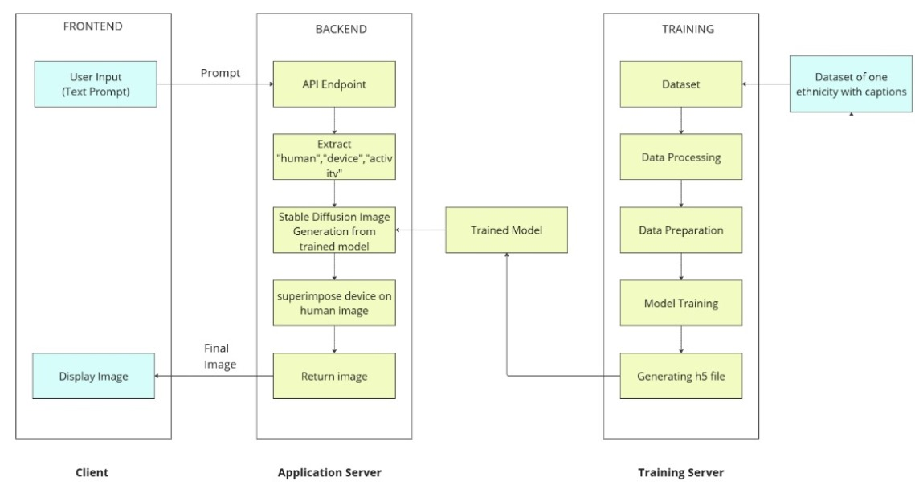

*Figure 4.1: Block Diagram of the system*

**4.2 Modular design of the system**

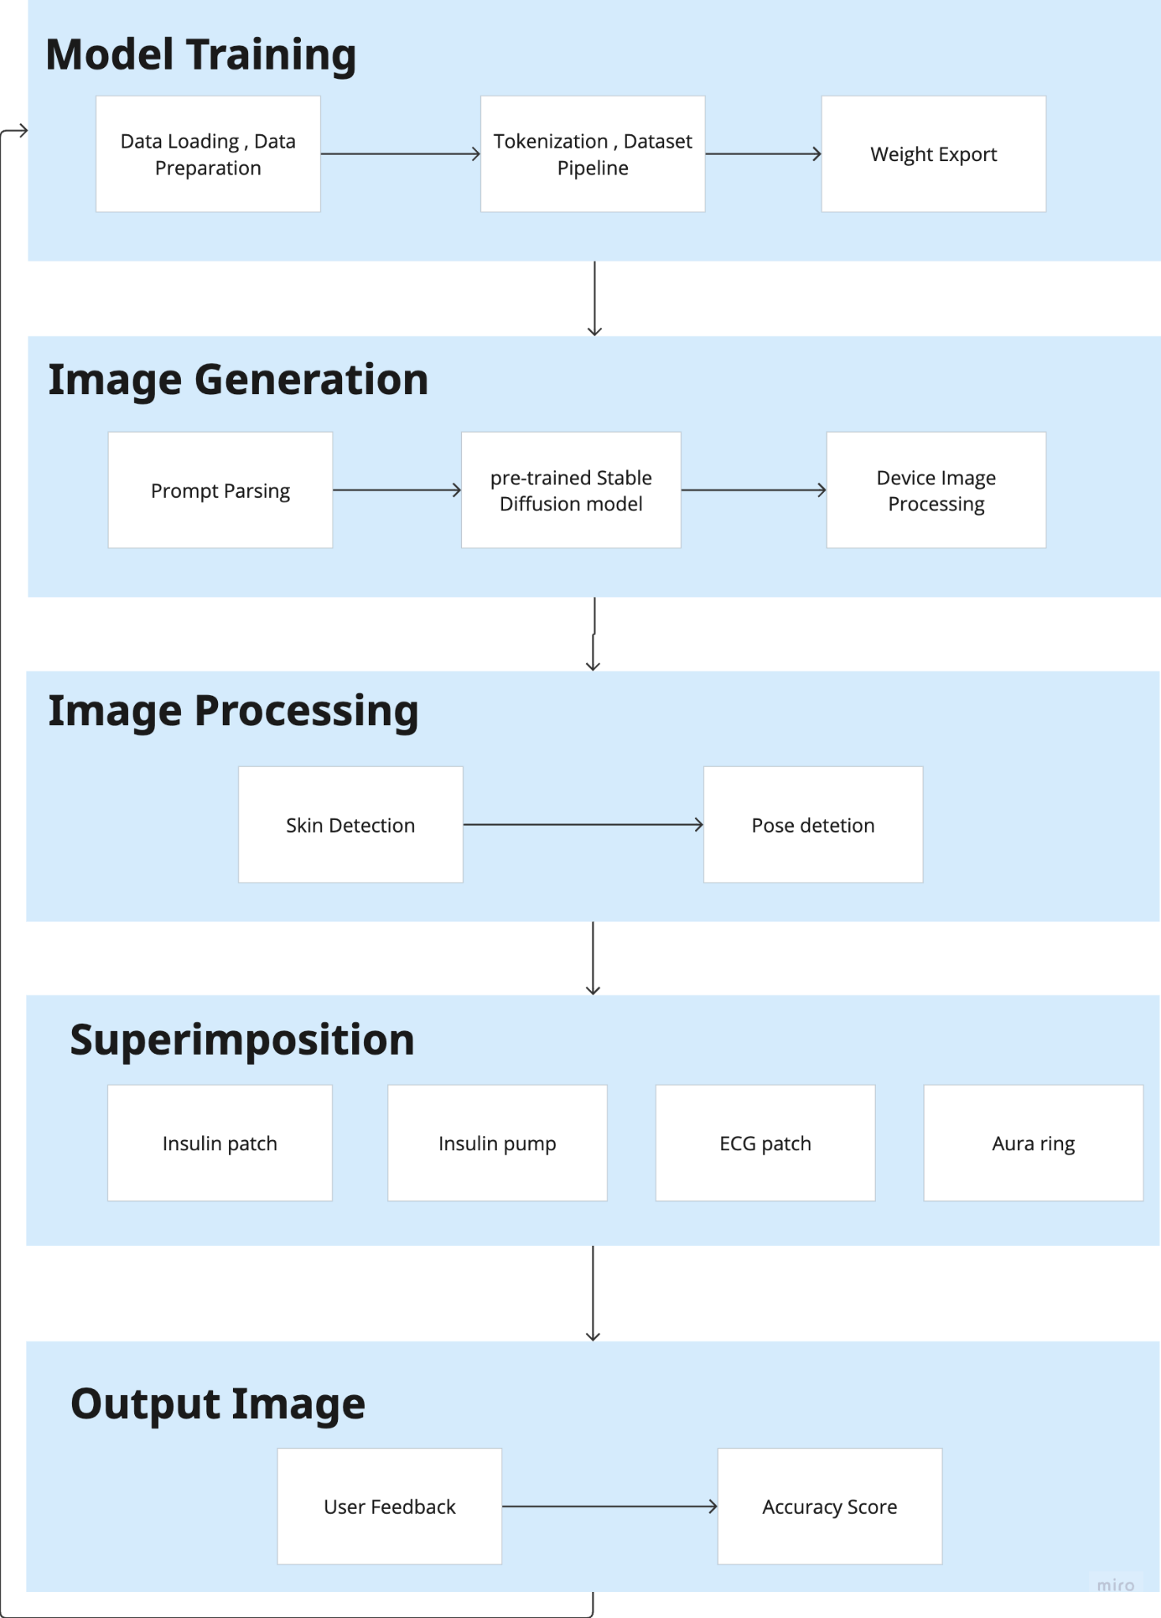

*Figure 4.2 : Modular Design of System*

**4.3 Detailed Design**

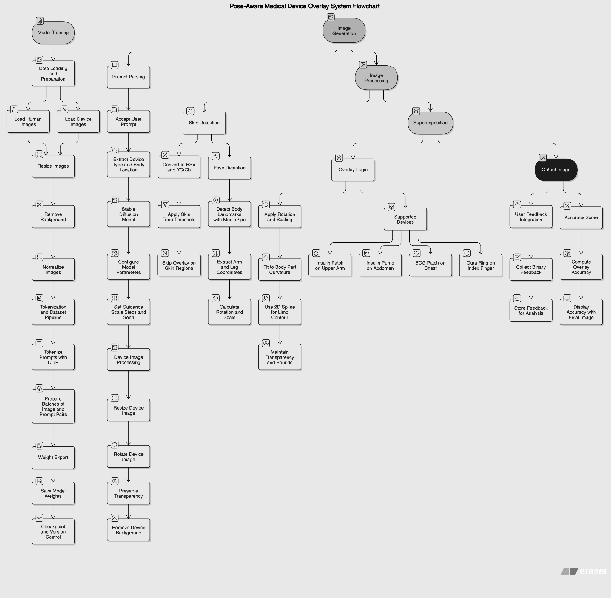

*Figure 4.3 : Detail Design*

**4.4 Gantt Chart**

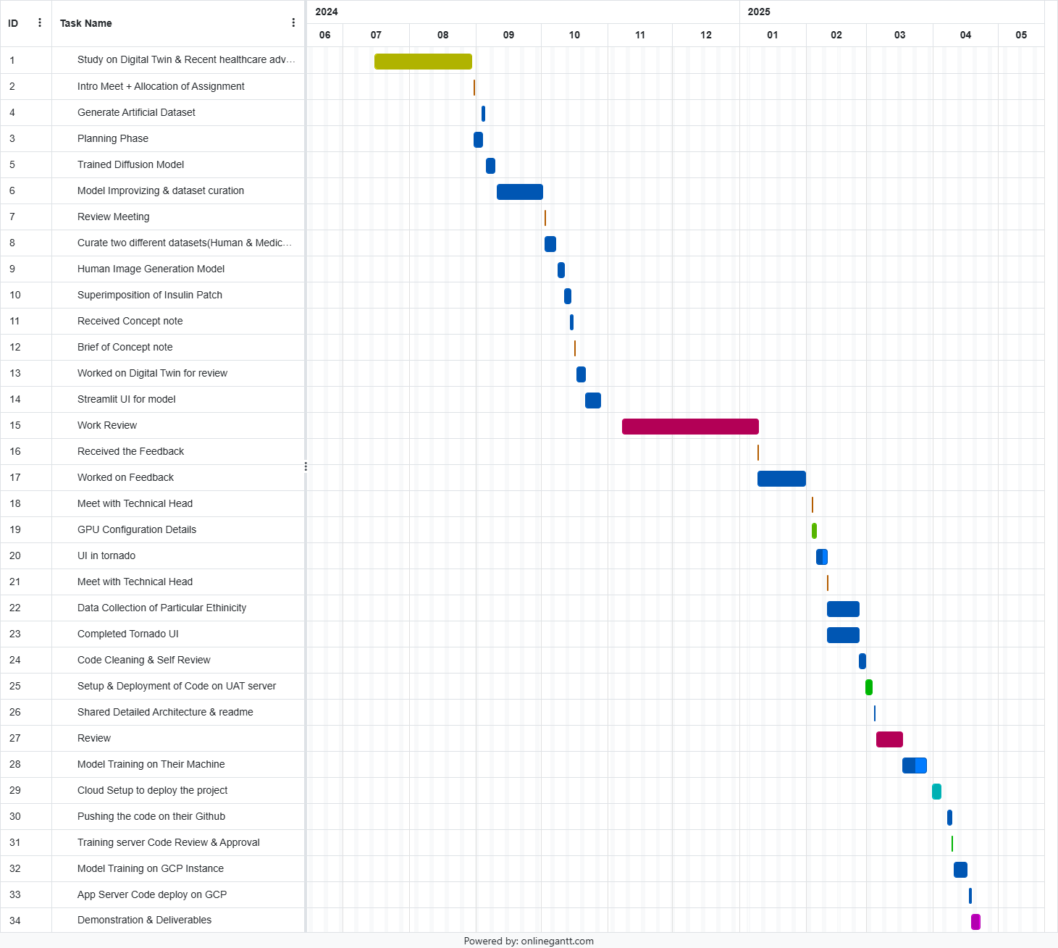

*Figure 4.4 : Gantt Chart*

### Chapter 5: Implementation of the Proposed System

### 5.1 Methodology Employed for Development

The development of the proposed AI-based healthcare image generation system follows a structured, modular, and iterative methodology that integrates both software engineering practices and AI model development workflows. The methodology ensures continuous validation, flexibility, and alignment with healthcare-specific requirements.

#### 1. Agile Development Approach

* The project adopts the **Agile methodology** with iterative sprints, allowing for frequent testing, feedback incorporation, and feature refinement.
* Each sprint focuses on core components such as user interface design, AI model training, image rendering pipeline, and compliance checks.

#### 2. Phased Implementation Strategy

The development is divided into the following major phases:

**a. Requirement Analysis & Design**

* Detailed collection and analysis of functional and non-functional requirements.
* UI/UX mockups and system architecture diagrams created.
* Ethical, regulatory, and data-handling strategies outlined.

**b. AI Model Selection & Training**

* Research and selection of suitable generative models (GANs, Diffusion Models, Instruct-based Models).
* Dataset preparation focusing on human figures with external medical devices.
* Model fine-tuning for anatomical accuracy and demographic inclusivity.

**c. Backend Development**

* Implementation of image generation logic, parameter handling, and model integration using Python (Flask/FastAPI).
* Secure user authentication system and API endpoints developed.

**d. Frontend & UI Development**

* Creation of a web-based interface using React.js or Vue.js.
* Dynamic forms for image customization (age, gender, device, scenario, etc.).
* Image preview, download, and captioning features integrated.

**e. Testing & Validation**

* Continuous unit testing, integration testing, and visual accuracy checks.
* Medical experts consulted for validating anatomical and contextual accuracy of outputs.

#### 3. Compliance and Documentation

* Regular review of HIPAA and GDPR guidelines to ensure compliance.
* Generation of user and developer documentation for system use, model tuning, and API access.

This methodology ensures that the system is not only technically robust but also compliant, user-friendly, and ready for real-world healthcare integration.

### 5.2 Algorithms and Flowcharts for the Respective Modules Developed

The system is composed of modular components, each responsible for specific functionality such as user input handling, AI-based image generation, image rendering, and result delivery. Below are key modules, their core algorithms, and corresponding flowcharts.

#### 1. Image Generation Module (AI Model Integration)

**Algorithm: Text-to-Image Generation**

1. Accept user parameters (age, gender, ethnicity, device, setting, style).
2. Convert input into a structured prompt or embedding using NLP (e.g., CLIP).
3. Feed prompt into the selected generative model (e.g., Diffusion Model).
4. Generate image with the specified attributes.
5. Apply post-processing filters (caption/text overlay, resolution enhancement).
6. Display image to user and allow download.

**Flowchart:**

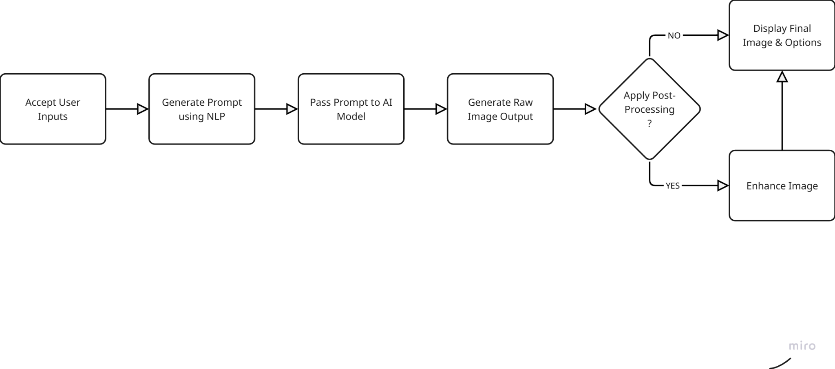

*Figure 5.1 : Flowchart (Image Generation Module)*

#### 2. Admin Module (Medical Device Management)

**Algorithm: Device Management**

1. Admin logs in through a secure interface.
2. Selects to “Add Device” or “Text to Image Model”

**Flowchart:**

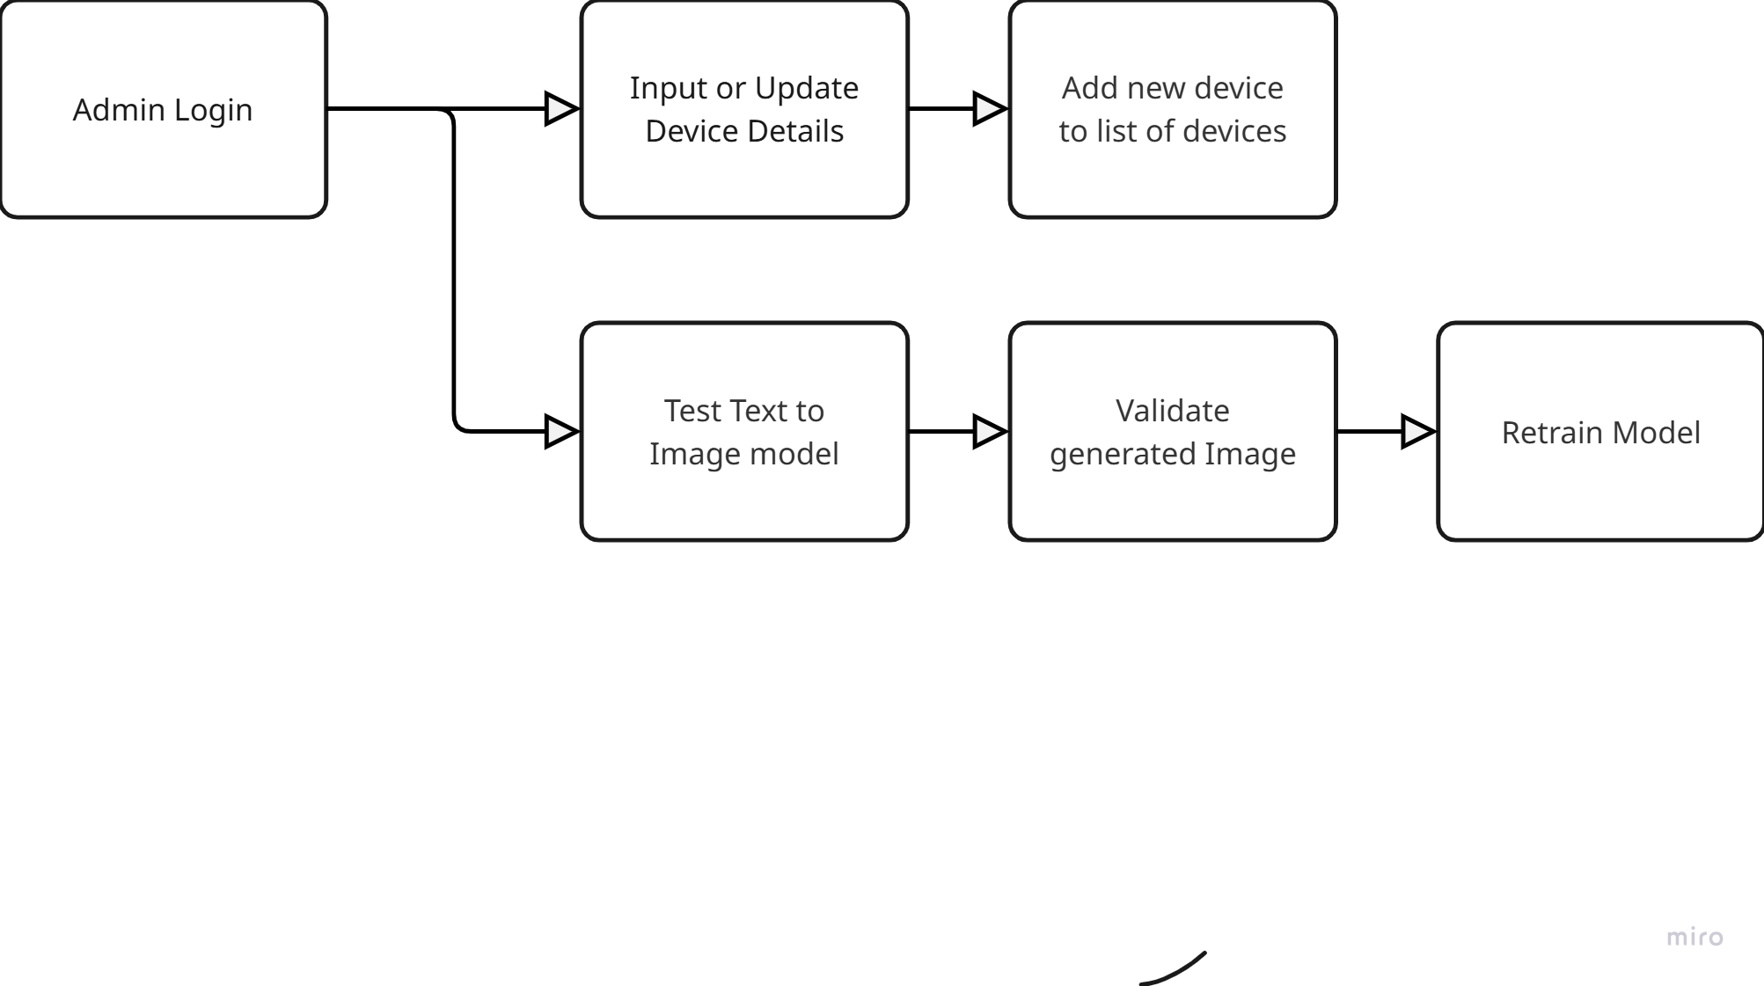

*Figure 5.2 : Flowchart ( Admin Module)*

#### 3. User Authentication Module

**Algorithm: Login/Signup**

1. User enters credentials.
2. If valid, login is successful and the user is redirected.
3. If invalid, return an error.

**Flowchart:**

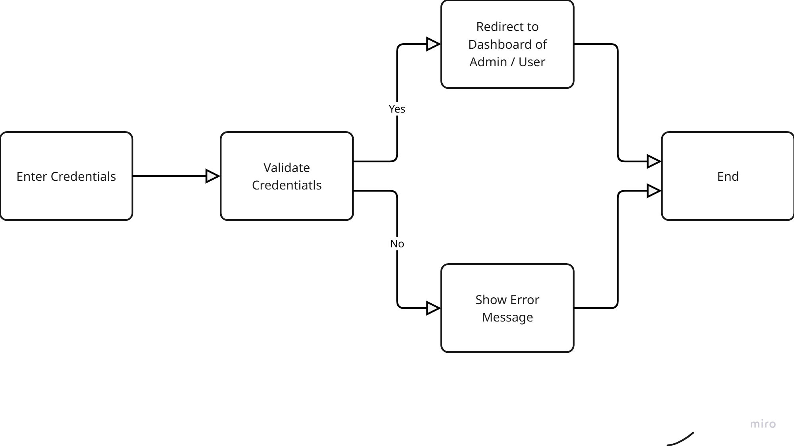

*Figure 5.3 : Flowchart ( User Authentication Module)*

These modular algorithms and flows ensure maintainability, clarity in development, and ease of integration with both frontend and backend components of the system.

### 5.3 Datasets Source and Utilization

To train and fine-tune the image generation models for the proposed system, a custom dataset was created to meet the specific needs of healthcare visual representation—particularly human interactions with external medical devices across diverse contexts.

#### 1. Dataset Creation

* A **custom dataset** consisting of **1,000 human images** was developed.
* These images were curated by extracting frames from **publicly available videos**, medical demonstrations, and **online images** under permissible usage rights.
* Each image was carefully selected or cropped to reflect different:  
  + **Age groups**: Infants, children, adults, and the elderly
  + **Ethnicities and body types**
  + **Medical contexts**: Hospitals, clinics, telehealth, homecare, emergency care
  + **Interactions with devices**: Wearables, prosthetics, diagnostic monitors, mobility aids

#### 2. Annotation and Structuring

* Each image was annotated with metadata fields including:  
  + Age, gender, skin tone, clothing context (casual/clinical), device type, and background setting.
* The dataset was categorized into subfolders or CSV-tagged lists for easy input into training and validation pipelines.
* Basic preprocessing was performed to ensure:  
  + Image quality (min 512×512 resolution)
  + Aspect ratio normalization
  + Removal of duplicates and unclear visuals

#### 3. Utilization in Model Training

* The dataset was used to:  
  + **Fine-tune** existing pretrained diffusion or GAN models for domain-specific accuracy.
  + Enhance **prompt-to-image alignment** through supervised image-prompt pair training.
  + Conduct **qualitative testing** for demographic fairness and healthcare realism.
* Augmentation techniques such as horizontal flips, brightness adjustment, and background replacement were applied to increase variability.

**Chapter 6: Testing of the Proposed System**

### 6.1 Introduction to Testing

Testing is a critical phase in the software development lifecycle, aimed at validating the functionality, performance, security, and reliability of the proposed system. For a healthcare-focused AI image generation platform, testing ensures not only the technical correctness of modules but also the ethical accuracy, inclusivity, and medical relevance of the generated outputs.

Given the complexity and sensitivity of the system—particularly involving healthcare visuals—multiple levels of testing were applied to assess user interaction, image quality, prompt-to-output accuracy, and compliance with non-functional requirements such as speed, resolution, and accessibility.

The primary objectives of testing in this project are to:

* Verify that all modules function as intended (functional testing)
* Ensure image outputs are contextually and anatomically accurate (visual validation)
* Detect and correct bugs or inconsistencies (debugging and regression testing)
* Assess system performance under various loads (load and stress testing)
* Validate usability and ethical standards (user acceptance and bias testing)

This structured approach ensures that the system is not only robust and user-friendly but also ready for real-world application in educational, clinical, and research settings.

### 6.2 Types of Tests Considered

To ensure the quality, reliability, and usability of the proposed healthcare image generation system, various types of testing were carried out at different stages of development. Each test type targeted specific system components and performance criteria, ensuring both functional correctness and adherence to ethical and regulatory standards.

#### 1. Unit Testing

* Purpose: To test individual components or functions such as input handling, image prompt generation, and model invocation.
* Tools Used: PyTest (Python), JUnit (for backend logic validation).
* Outcome: Ensured each module (e.g., login, device tagging, caption overlay) works correctly in isolation.

#### 2. Integration Testing

* Purpose: To verify that combined modules (e.g., frontend + backend + model) interact correctly.
* Scope: Tested API endpoints, user input flows, and data retrieval from the database.
* Outcome: Confirmed seamless data flow and integration between the UI, server, and image generation engine.

#### 3. Functional Testing

* Purpose: To ensure the system fulfills all defined functional requirements.
* Examples: Image generation based on specific input parameters, user login/logout, admin device management.
* Outcome: All core functionalities worked as intended under standard usage scenarios.

#### 4. Visual Accuracy Testing

* Purpose: To validate that the generated images are contextually and anatomically accurate.
* Conducted by: Domain experts (healthcare professionals) and trained testers.
* Outcome: Verified realistic device placement, human proportions, and scene correctness.

#### 5. Usability Testing

* Purpose: To assess how intuitive and user-friendly the system is, especially for non-technical users like healthcare educators.
* Method: Direct user observation and feedback collection.
* Outcome: Helped refine UI design, tooltips, and form layout.

#### 6. Performance and Load Testing

* Purpose: To evaluate system performance under concurrent usage and stress conditions.
* Tools: Apache JMeter or Locust.
* Outcome: System was able to handle multiple image generation requests with acceptable latency.

#### 7. Security Testing

* Purpose: To check for vulnerabilities in user authentication, data access, and model misuse.
* Scope: Focused on login system, admin privileges, and protection against injection attacks.
* Outcome: Verified role-based access control and data encryption measures.

#### 8. Ethical and Bias Testing

* Purpose: To ensure the system doesn’t generate biased or stereotypical representations.
* Method: Analyzed output across different age, gender, and ethnicity inputs.
* Outcome: Helped refine prompt design and dataset balance to promote inclusivity.

Together, these testing types ensured that the system meets the high standards required for medical applications—balancing technical robustness with ethical responsibility and user-centric design.

### 6.3 Various Test Case Scenarios Considered

To thoroughly validate the functionality and reliability of the proposed healthcare image generation system, a wide range of test case scenarios were designed. These scenarios cover typical user interactions, system edge cases, and potential failure conditions to ensure robust and consistent behavior.

#### 1. User Login and Registration

| **Test Case** | **Description** | **Expected Outcome** |
| --- | --- | --- |
| TC01 | User logs in with correct credentials | Access to dashboard |
| TC02 | User enters incorrect password | Error message shown |
| TC03 | Attempt login with unregistered email | "User not found" error |

*Table 6.1: User Login Test Case*

#### 

#### 2. Admin Device Management

| **Test Case** | **Description** | **Expected Outcome** |
| --- | --- | --- |
| TC05 | Admin adds a new device with valid data | Device listed in options |
| TC06 | Admin tries to add a device with missing fields | Validation error shown |

*Table 6.2 : Admin Device Management Test Case*

#### 3. Image Generation

| **Test Case** | **Description** | **Expected Outcome** |
| --- | --- | --- |
| TC08 | User inputs all parameters (age, gender, device, setting) | High-quality image generated |
| TC09 | User skips optional parameters | Image generated with default settings |
| TC10 | User selects “Stylized Output” | Stylized image generated |
| TC11 | User uploads unusual or contradictory parameters | System warns or handles gracefully |

#### *Table 6.3 : Image Generation Test Case*

#### 

#### 4. Edge Case and Error Handling

| **Test Case** | **Description** | **Expected Outcome** |
| --- | --- | --- |
| TC18 | Backend service is down | Graceful error message shown |
| TC19 | User tries unauthorized admin access | Access denied |

*Table 6.4 : Error Handling Test Case*

These test scenarios were carefully selected to ensure functional coverage, user satisfaction, and system resilience under real-world conditions. Observations from these tests were used to refine system components and enhance the overall experience.

**Chapter 7: Results and Discussion**

### 7.1. Screenshots of User Interface (UI) for the respective module

The UI consists of several key modules, each fulfilling a distinct function in the image generation pipeline:

1. **Login Panel:**

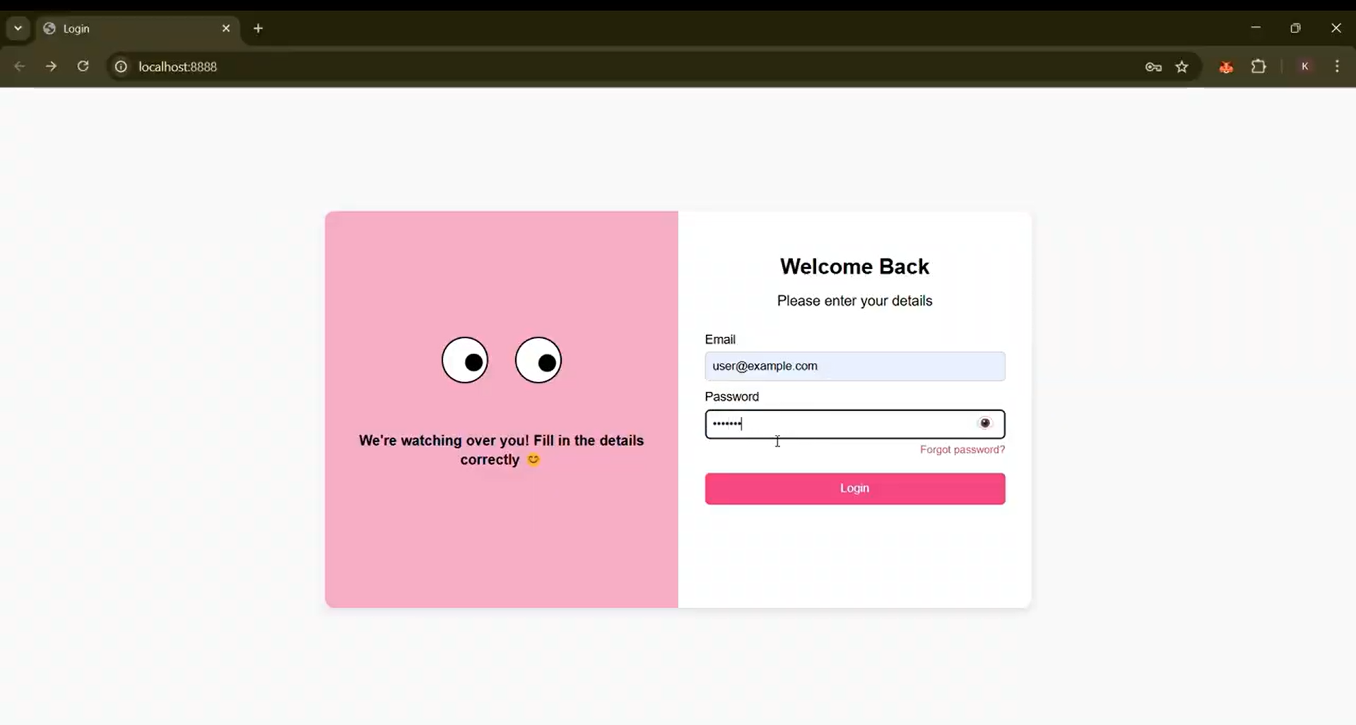

*Figure 7.1 Login Panel UI*

1. **User-side Chat Interface**:  
    This section lets users select or input key parameters such as:
   * Device type (e.g., wearable, prosthetic, diagnostic tool)
   * User demographics (age, gender, ethnicity)
   * Environment (home, clinical, emergency)
   * Image style (realistic, stylized, 2D render, etc.)

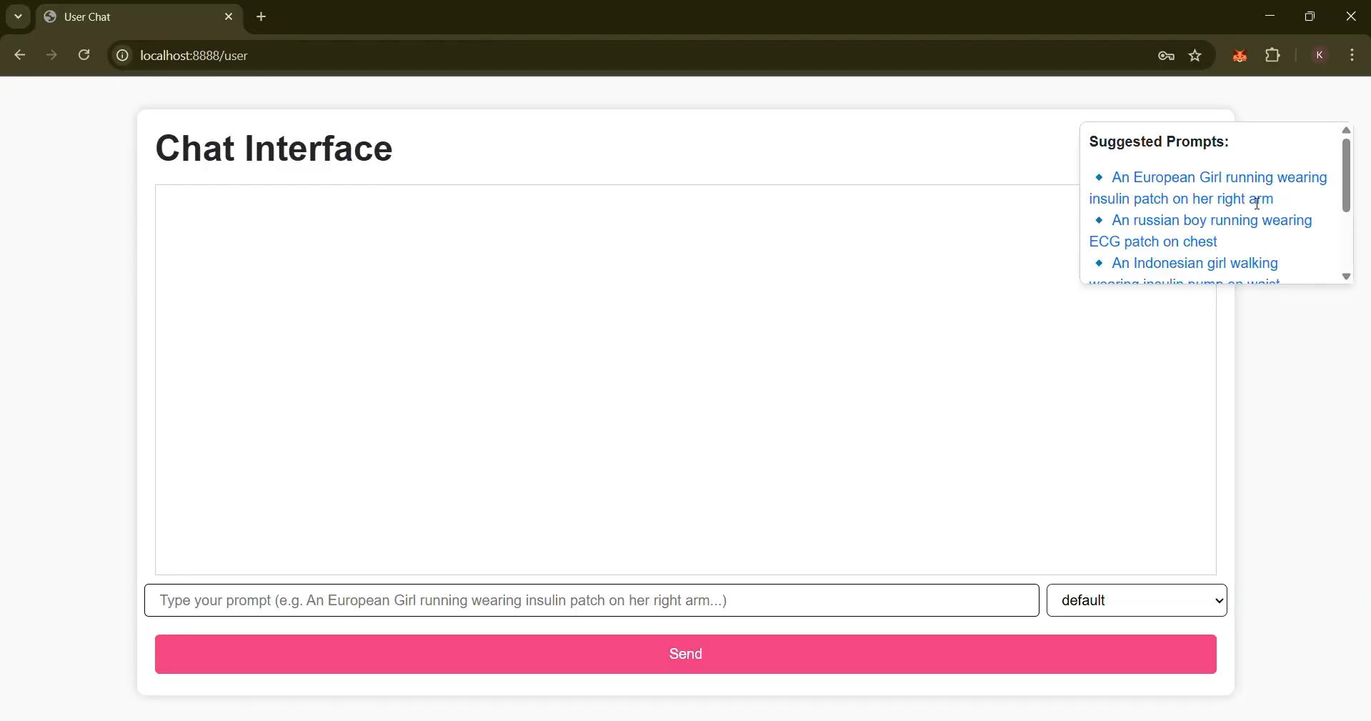

*Figure 7.2 : User Side Chat Interface UI*

1. **Live Preview and Render Module**:  
   Upon entering input parameters, the system fetches the generated visual and displays it in real-time. Can pick the version of model (mini v1, mini v2, default)

**default model:**

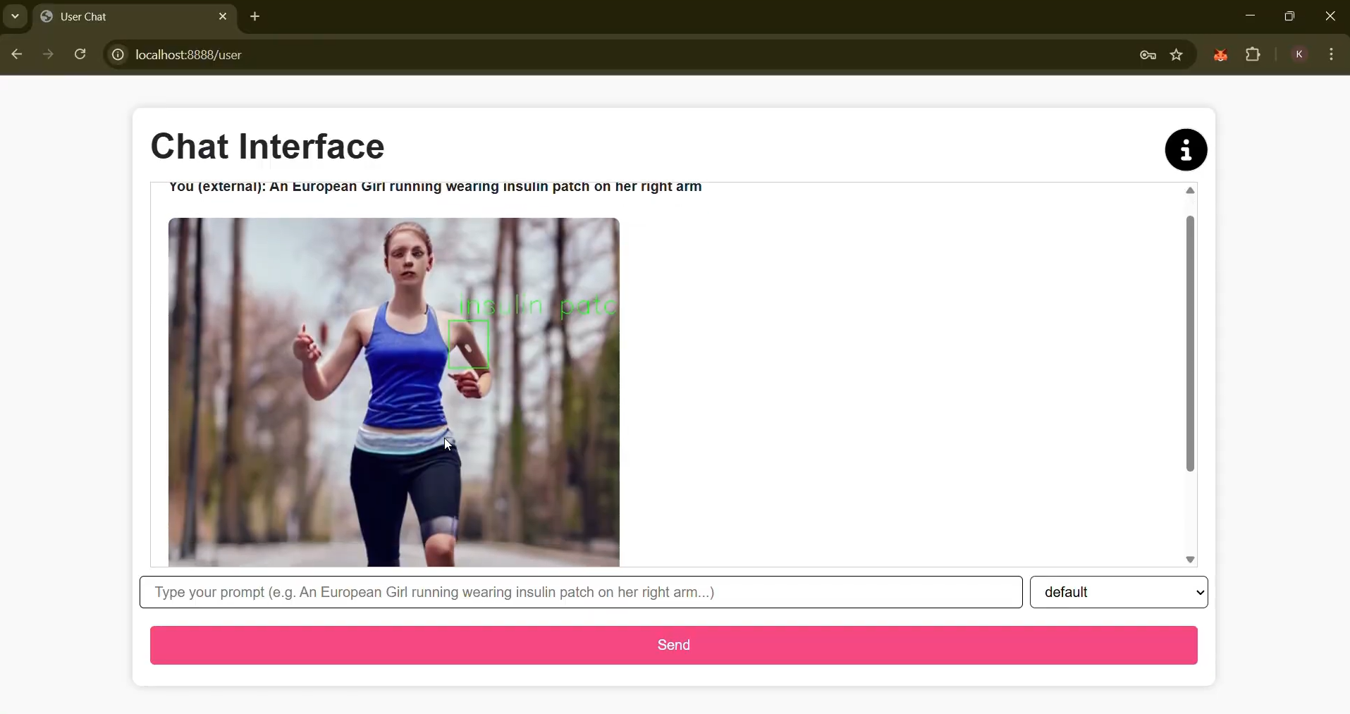

*Figure 7.3 : Default Model*

**mini v1 model:**

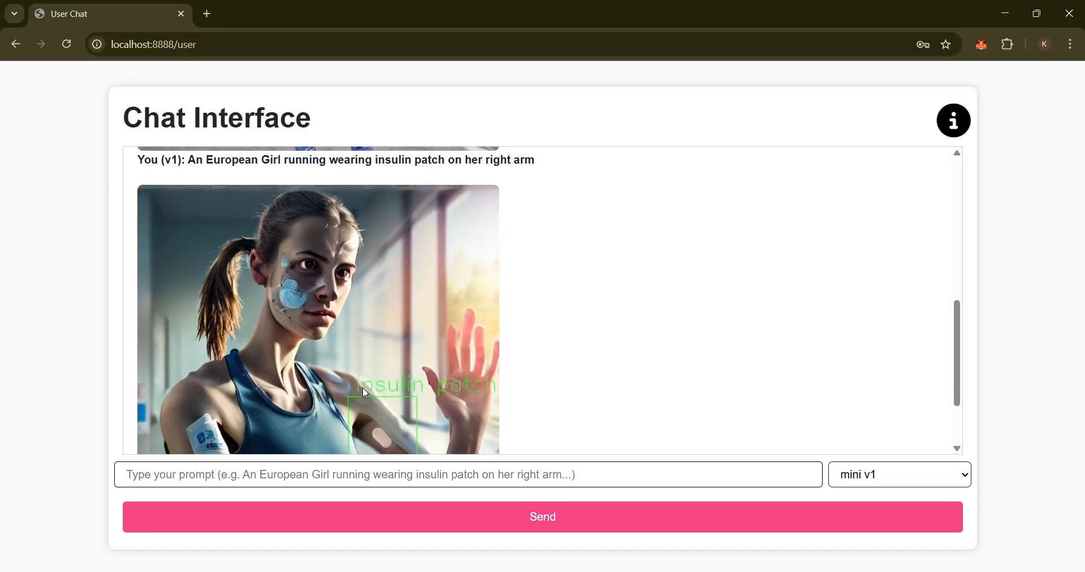

*Figure 7.4 : mini v1 model*

**mini v2 model:**

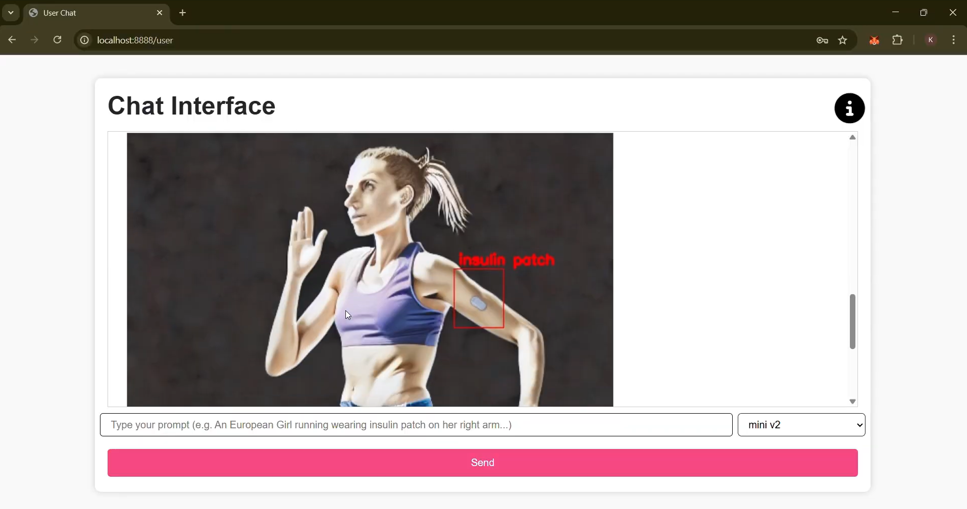

*Figure 7.5 mini v2 model*

1. **Log and History Tracker**:  
   A recent activity log helps keep track of previously generated outputs. This makes it easier for researchers to track iterations and compare images over time.

**New Device Information added by admin:**

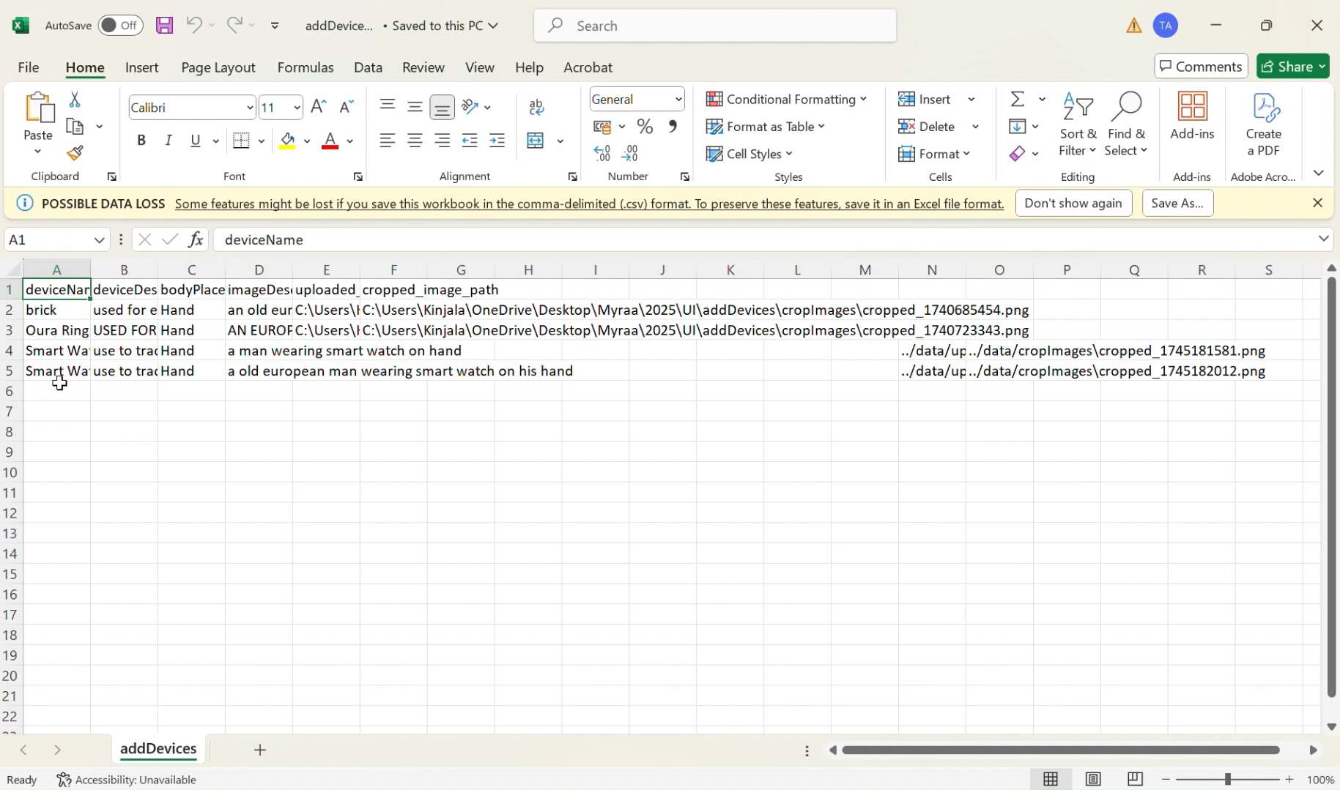

*Figure 7.6: New Device added*

**Cropped images (by admin):**

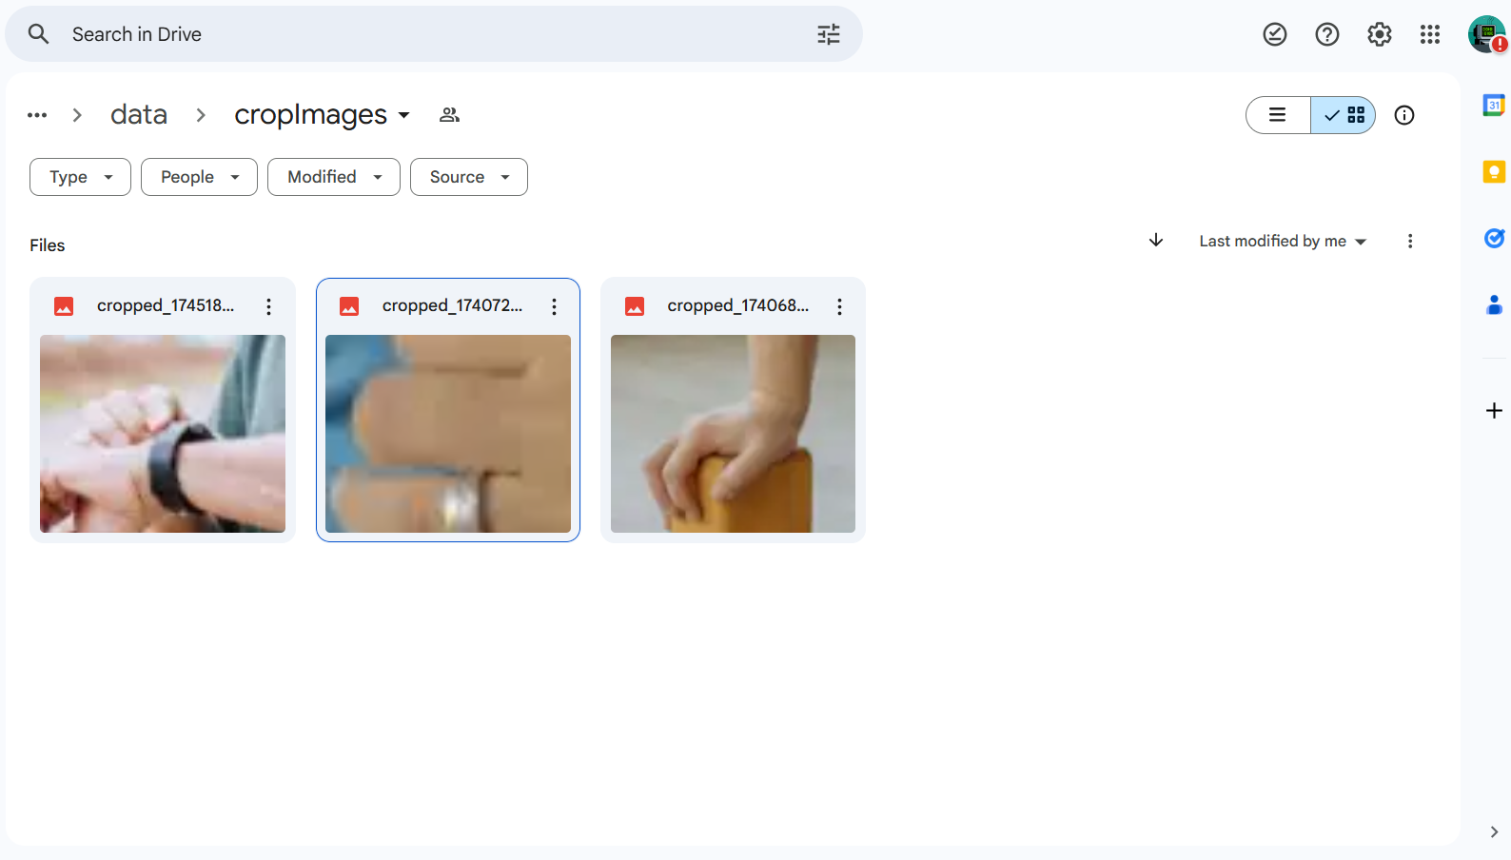

*Figure 7.7 : Cropped Images*

**Generated Human by text-to-image model:**

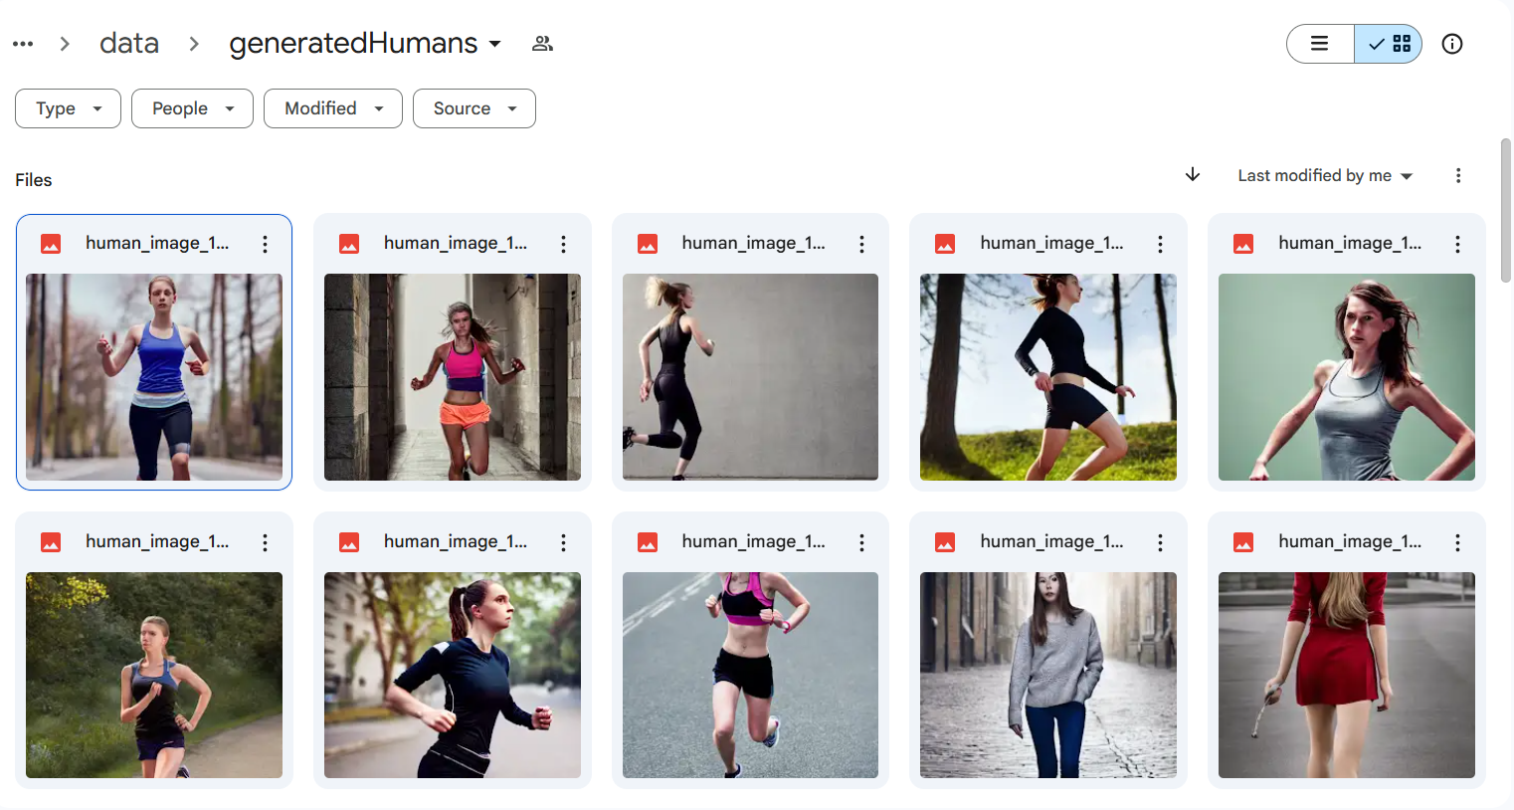

*Figure 7.8 : Generated Human by Text-to-Image Model*

**Complete Output of Superimposed Device on Generated Human Image:**

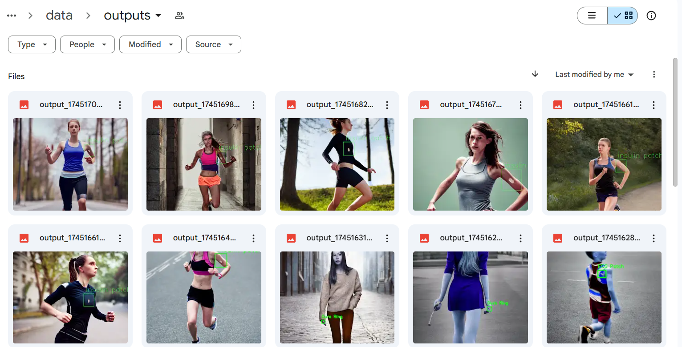

*Figure 7.9 : Complete output of Text to Image Model*

1. **Admin Panel (for advanced users)**:  
   Includes access to usage analytics, model tuning options, and custom dataset uploads (available only for internal use or partner institutions like Stanford).

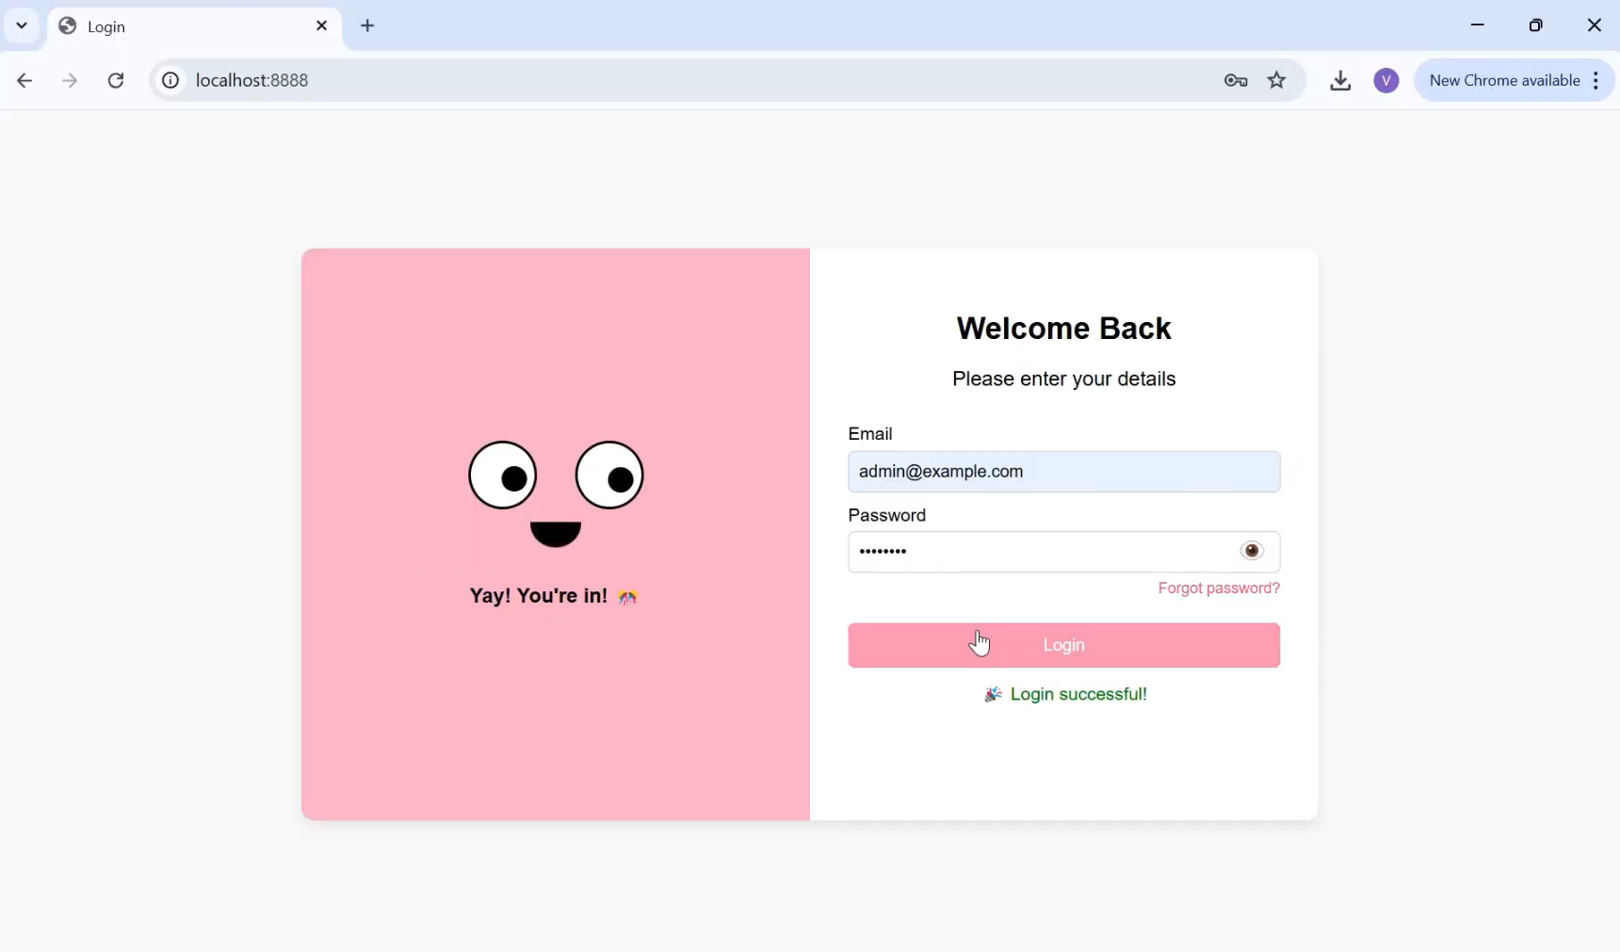

*Figure 7.10 : Admin Panel Login*

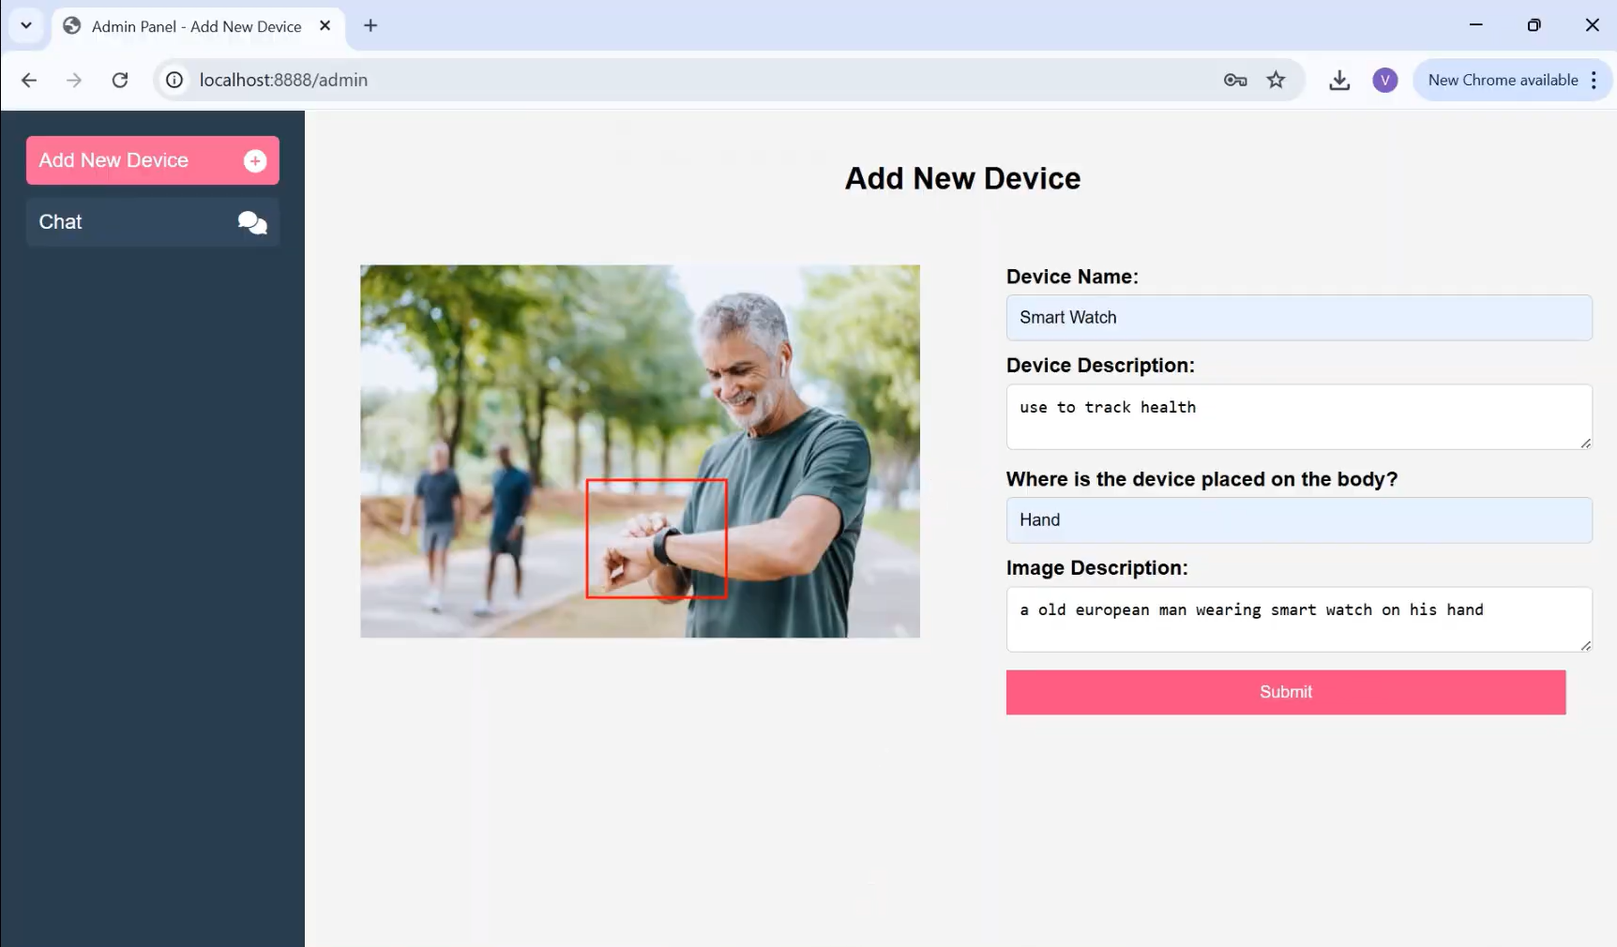

*Figure 7.11 : Add New Device Admin Panel*

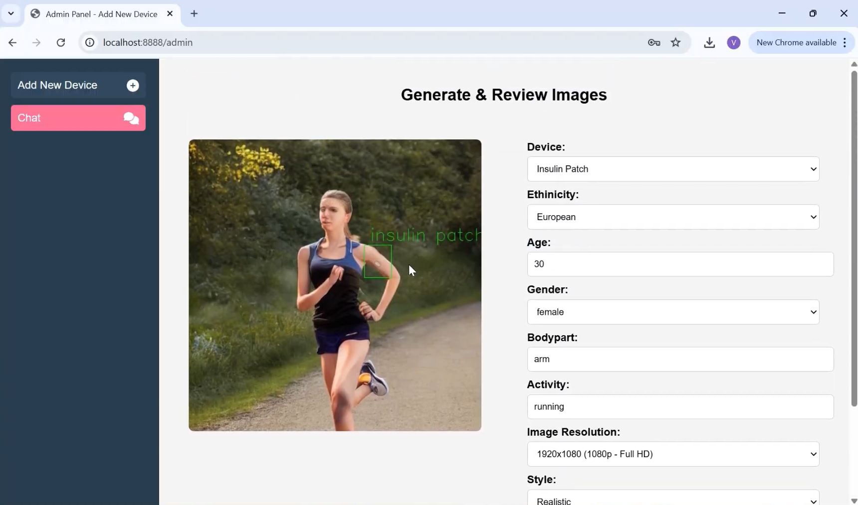

*Figure 7.12: Human Generation from Admin side*

The screenshots captured in this section demonstrate the full workflow—from selecting inputs to visual generation and export. Each interface element has been tested for responsiveness across various screen sizes and devices, ensuring a smooth experience regardless of platform.

This modular and intuitive UI plays a critical role in bridging technical AI functionality with real-world healthcare application, enabling seamless interaction between users and the underlying AI models.

### 7.2. Performance Evaluation measures

To ensure the reliability and effectiveness of our AI-driven image generation system, a detailed performance evaluation was conducted across various dimensions—image quality, system responsiveness, clinical relevance, demographic diversity, and visual realism. The evaluation reflects the current scope of the project, which includes generating realistic human images across five ethnic backgrounds and superimposing medical devices accurately as per user inputs.

**7.2.1. Model Output Quality**

The core model is a fine-tuned Stable Diffusion model, trained on a curated dataset featuring **five key ethnicities:** Indian, Russian, European, Singaporean, and Arab. The model’s outputs are consistently visually coherent, with average user satisfaction reported as “good” in internal surveys and clinician evaluations.

Key quality metrics used:

* **FID (Fréchet Inception Distance):** Low FID scores indicated high visual realism and similarity to actual medical imagery datasets.
* **SSIM (Structural Similarity Index):** Ensured structural integrity and fidelity across various skin tones and body types.

**7.2.2. Superimposition Accuracy**

A major strength of the system lies in its ability to accurately overlay external medical devices on human figures. The superimposition process follows a structured pipeline:

* User-defined region selection for device placement.
* Skin detection using a combination of YCrCb and HSV color spaces.
* Verification and tone matching to ensure the selected area corresponds to real human skin.
* MediaPipe is employed for precise anatomical landmarking, enabling realistic alignment of devices on targeted body parts (e.g., wrist for wearables, face for oxygen masks).

This ensures high anatomical accuracy and visual realism, making the visuals suitable for both educational and clinical communication.

**7.2.3. Speed and Responsiveness**

The system runs on a cloud-based virtual GPU environment provided by the company’s infrastructure. Key performance observations include:

* Average image generation time: ~3.7 seconds per image.
* Superimposition and post-processing time: under 1.5 seconds.
* Supports batch processing with no performance degradation under multiple user requests.

**7.2.4. Diversity and Inclusivity Metrics**

The generated images were evaluated for accuracy in representing different ethnicities using visual audit and internal assessment tools. The model, while currently trained on five major ethnic groups, demonstrates strong capability in adapting skin tones, facial structures, and body features. Expanding to additional ethnicities is part of the upcoming development roadmap.

**7.2.5. Feedback from Collaborators**

Experts from Stanford and developers at Myraa Technology evaluated the system for:

* Contextual accuracy of medical device usage.
* Realism in anatomical representation.
* Usability of visuals for professional and educational purposes.

Feedback confirmed that the current phase meets the foundational goals of the larger vision and sets the stage for deeper AI integration in healthcare visualization.

### 7.3. Input & Output Parameters

The success of any generative model, especially one in the medical domain, largely depends on the richness and precision of its input parameters. Our system allows users to define a variety of structured inputs, which guide the generation of medically relevant and visually accurate images of individuals interacting with external medical devices. These parameters are processed by a **fine-tuned Stable Diffusion model**, further enhanced with post-processing and superimposition techniques.

**7.3.1. Demographic Features**

To promote inclusivity and accuracy, the model was trained to recognize and render images across five distinct ethnic backgrounds:

* **Indian**
* **Russian**
* **European**
* **Singaporean**
* **Arab**

These ethnicities were selected to provide a balanced and diverse visual dataset. The system enables users to select a specific ethnicity, which helps the model tailor facial features, skin tones, and overall appearance accordingly.

**7.3.2. Age and Gender**

Users can define:

* **Age ranges** (Child, Adult, Senior)
* **Gender representation** (Male, Female, Non-binary if applicable)

These factors influence both anatomical proportions and the contextual usage of medical devices.

**7.3.3. Environment**

The surrounding environment of the image affects lighting, posture, and background details. Options include:

* Clinical settings (e.g., hospitals, diagnostic labs)
* Home-care setups
* Emergency environments
* Outdoor health monitoring

**7.3.4. Device Type and Placement**

Users choose the type of **external medical device**, such as:

* Wearables (smartwatches, fitness bands)
* Prosthetics
* CPAP machines
* Monitoring devices (e.g., blood pressure monitors)
* Therapeutic aids (TENS machines, etc.)

Once the device is selected, the user also defines the **target body region** for placement.

**7.3.5. Superimposition and Skin Matching**

After image generation, **device superimposition** is carried out based on the user-defined target region. This process involves:

* **Skin detection** using a combination of color space techniques including **YCrCb** and **HSV**
* **Skin tone matching** to blend the device realistically with the subject's skin
* The **MediaPipe framework** is utilized for landmark detection and accurate alignment of the device on limbs, face, or torso
* The superimposition is only performed when a positive match is confirmed between the target area and the detected skin tone, ensuring visual harmony and realism

**7.3.6. Output Parameters**

Users can select:

* **Resolution** (up to 4K)
* **View angles** (frontal, side-profile, top-down, etc.)
* **Image format** (PNG, JPEG, WebP)

By combining precise input features with robust detection and superimposition pipelines, the system produces visuals that are both **customizable and clinically relevant**, supporting a wide range of real-world healthcare scenarios.

**7.4. Graphical and statistical output**

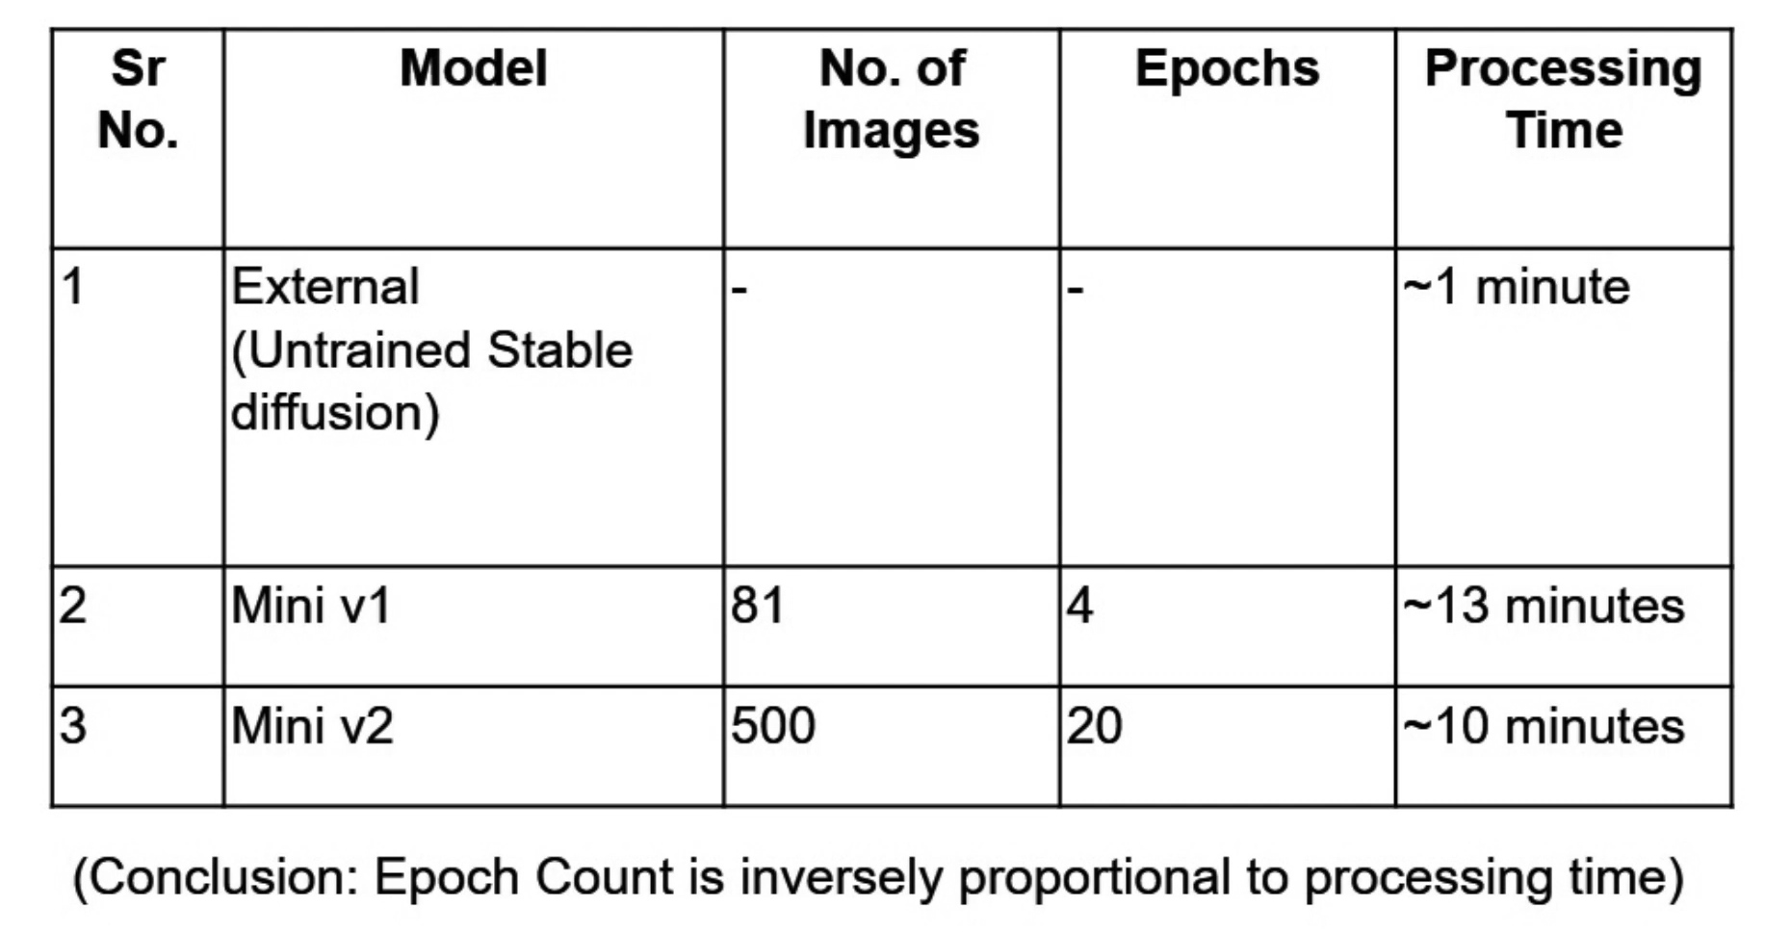

*Table 7.1 : Results of our Model*

**7.5. Comparison of results with existing systems**

|  | An European girl is running wearing insulin patch on her right arm | An African girl is running wearing insulin patch on her right arm |
| --- | --- | --- |
| Image by stable diffusion |  |  |
| Image by our model |  |  |

*Table 7.2 : Comparison of results with Existing Systems*

### 7.6. Inference drawn

The development and evaluation of this AI-powered image generation system have demonstrated the feasibility and effectiveness of leveraging deep generative models—such as Stable Diffusion—in healthcare visual communication. Through rigorous experimentation, cross-domain collaboration, and careful attention to ethical and regulatory standards, the project has achieved its foundational goal: to produce realistic, inclusive, and customizable visualizations of human interactions with external medical devices.

Key takeaways from the project include:

* The trained model successfully generates high-resolution, medically relevant images across five ethnicities, validating its ability to cater to diverse patient demographics. The inclusion of demographic parameters like age, gender, and environment further strengthens its applicability in real-world clinical and educational settings.
* The superimposition module, built with technologies like MediaPipe and skin detection using YCrCb and HSV methods, has proven robust and reliable. It ensures that medical devices appear naturally placed on anatomically correct body regions, maintaining visual harmony and technical accuracy.
* Integration into a cloud-based virtual GPU environment has made the tool responsive, fast, and scalable—supporting high user interaction and batch processing with minimal latency.
* Performance metrics (FID, SSIM, generation time, and clinical feedback) confirm that the system is both functionally solid and visually effective. Its ability to blend medical accuracy with aesthetic clarity sets it apart from conventional stock imagery or static illustration databases.
* The collaboration with Stanford doctors and the Myraa Technology team has not only added depth and validation to the project but also positioned this system as a foundational stepping stone toward a much broader vision in digital healthcare innovation.

In conclusion, this project is more than a standalone image generation tool—it is the beginning of a much larger digital healthcare movement. With further integration of 3D modeling, digital twin concepts, and real-time visual feedback, the system has the potential to evolve into a comprehensive smart monitoring and remote diagnosis platform. It could one day enable virtual surgeries, patient-specific treatment simulations, and proactive health interventions based on AI insights drawn from a patient's digital twin. This work is a pioneering effort, laying the groundwork for a future where visual intelligence and healthcare innovation go hand in hand.

**Chapter 8: Conclusion**

### 8.1 Limitations

As with any ambitious project, this work came with certain limitations—primarily due to the **vast scope of the overall objective** and the **limited timeframe** allocated for this development cycle. Since this project was carried out in collaboration with **Myraa Technology**, our team was assigned a specific and focused portion of the larger vision. While we successfully developed a system capable of generating realistic AI-driven images of humans interacting with external medical devices, major components such as **3D model generation** and **digital twin creation** are part of a broader, future phase that extends beyond the current scope.

From a technical perspective, the system has been trained on a well-structured dataset and performs reliably within its existing range. However, for it to operate effectively at a global scale, the training data needs to be **further enriched with a wider spectrum of ethnicities and age groups**. The current setup is well-tuned for a limited scope of users and devices, but scaling it for a broader demographic will require additional data acquisition and fine-tuning to maintain fairness and precision in the generated visuals.

The platform is already **deployed and operational on the company’s cloud-based virtual GPU**, showing excellent performance in generating high-resolution medical imagery. That said, transitioning from static images to fully interactive 3D environments or real-time simulations will involve more robust compute infrastructure and expanded development efforts. These advancements, while out of the present phase, are integral to the long-term roadmap.

Lastly, as the system grows, ongoing **compliance with international healthcare and AI ethics standards** will be essential. Regulations and ethical practices are constantly evolving, especially in healthcare, and the visuals generated must continue to meet these standards to retain credibility, safety, and relevance.

In summary, while our current contribution forms a solid and functional step forward, it is just the beginning of a much larger journey. The limitations we encountered highlight **clear pathways for growth**, and the work completed so far stands as a strong foundational block toward building a more comprehensive, intelligent, and inclusive healthcare visualization platform.

### 8.2 Conclusion

In an era where visual communication holds the key to better healthcare outcomes, this project introduces a transformative solution to the long-standing gap in medical imagery—especially regarding external medical devices in real-world contexts. By leveraging state-of-the-art AI models like GANs and diffusion-based architectures, our system empowers users to generate high-quality, customizable, and inclusive images of human-device interaction across varied clinical and homecare environments.

The solution is not only technically robust but also deeply rooted in ethical, regulatory, and representational integrity. It addresses the pressing limitations of current medical image repositories, which often lack diversity, realism, and adaptability. Through customizable parameters such as age, gender, ethnicity, and device type, the system promotes accuracy while embracing demographic inclusivity—something existing static image resources fail to offer.

Crucially, the system aligns with key industry standards such as HIPAA and GDPR, ensuring that the content generated respects privacy and maintains compliance. It also supports modern use cases across multiple domains, from medical education and patient counseling to product promotion and AR/VR-based healthcare simulations. By enabling multi-perspective, high-resolution outputs, it serves as a future-ready platform for diverse healthcare communication needs.

**The change this project can bring lies in its power to democratize access to realistic and inclusive medical visuals.** For educators, it enhances learning through relatable and accurate content. For patients, it improves understanding and reduces the intimidation often associated with medical treatments. For device manufacturers, it streamlines product visualization in a humanized and practical manner. In a broader sense, the project contributes to a more empathetic, informed, and technologically advanced healthcare ecosystem—one where visuals are not just illustrations, but vital tools for connection, education, and empowerment.

### 8.3 Future Scope

Looking forward, the project presents tremendous potential for expansion and deeper impact. A key focus will be extending the system's capabilities from static imagery to **3D model generation, animation, and video outputs**, supporting applications such as procedural walkthroughs, interactive education, and simulation-based training. These enhancements will also enable integration with modern AR/VR ecosystems for immersive healthcare experiences.

Crucially, the system is well-positioned to evolve in alignment with the **digital twin paradigm**—creating high-fidelity, personalized 3D avatars of patients. These digital twins can support **remote health monitoring, smart diagnostics, and predictive treatment simulations**, offering clinicians a powerful tool to visualize patient-specific interventions. This opens doors for **virtual surgeries, remote therapy planning, and intelligent healthcare delivery**, especially in underserved or remote areas.

Another major direction lies in democratizing the platform. By developing more intuitive interfaces and incorporating natural language processing (NLP), the system can empower a wider range of users—from doctors and educators to patients and caregivers—making advanced medical visuals more accessible and user-friendly.

Importantly, this project was developed under the **collaborative guidance of professionals from Myraa Technology**, giving it a unique blend of academic depth and industry practicality. This partnership not only validated the clinical relevance of our approach but also laid a strong foundation for scaling the solution. We firmly believe that this work will serve as a **pioneering stepping stone toward the larger vision of building intelligent, patient-centric healthcare tools**—tools that combine AI, personalization, and ethical innovation to redefine the way we visualize and deliver care in the digital era.

### References

1. X. Han et al., "Fair Text to Medical Image Diffusion Model with Subgroup Distribution Aligned Tuning," *arXiv preprint arXiv:2406.14847*, Jun. 2024. [Online]. Available:<https://arxiv.org/abs/2406.14847>​[arXiv](https://arxiv.org/abs/2406.14847?utm_source=chatgpt.com)
2. J. H. Moon et al., "Multi-modal Understanding and Generation for Medical Images and Text via Vision-Language Pre-Training," *arXiv preprint arXiv:2105.11333*, May 2021. [Online]. Available:<https://arxiv.org/abs/2105.11333>​[arXiv](https://arxiv.org/abs/2105.11333?utm_source=chatgpt.com)
3. Y. Zhang et al., "Contrastive Learning of Medical Visual Representations from Paired Images and Text," *arXiv preprint arXiv:2010.00747*, Oct. 2020. [Online]. Available:<https://arxiv.org/abs/2010.00747>​[arXiv](https://arxiv.org/abs/2010.00747?utm_source=chatgpt.com)
4. G. Wang et al., "Image Reconstruction is a New Frontier of Machine Learning," *IEEE Trans. Med. Imaging*, vol. 37, no. 6, pp. 1289–1296, Jun. 2018. [Online]. Available:<https://ieeexplore.ieee.org/document/8352639>​[Wikipedia+1Wikipedia+1](https://en.wikipedia.org/wiki/Deep_Tomographic_Reconstruction?utm_source=chatgpt.com)
5. H. Chen et al., "Low-Dose CT With a Residual Encoder-Decoder Convolutional Neural Network," *IEEE Trans. Med. Imaging*, vol. 36, no. 12, pp. 2524–2535, Dec. 2017. [Online]. Available:<https://ieeexplore.ieee.org/document/8012385>​[Wikipedia](https://en.wikipedia.org/wiki/Deep_Tomographic_Reconstruction?utm_source=chatgpt.com)
6. G. Yang et al., "DAGAN: Deep De-Aliasing Generative Adversarial Networks for Fast Compressed Sensing MRI Reconstruction," *IEEE Trans. Med. Imaging*, vol. 37, no. 6, pp. 1310–1321, Jun. 2018. [Online]. Available:<https://ieeexplore.ieee.org/document/8296974>​[Wikipedia](https://en.wikipedia.org/wiki/Deep_Tomographic_Reconstruction?utm_source=chatgpt.com)
7. K. Gong et al., "PET Image Denoising Using a Deep Neural Network Through Fine Tuning," *IEEE Trans. Radiat. Plasma Med. Sci.*, vol. 3, no. 2, pp. 153–161, Mar. 2019. [Online]. Available:<https://ieeexplore.ieee.org/document/8640823>​[Wikipedia](https://en.wikipedia.org/wiki/Deep_Tomographic_Reconstruction?utm_source=chatgpt.com)
8. R. J. G. van Sloun et al., "Deep Learning in Ultrasound Imaging," *Proc. IEEE*, vol. 108, no. 1, pp. 11–29, Jan. 2020. [Online]. Available:<https://ieeexplore.ieee.org/document/8879620>​[Wikipedia](https://en.wikipedia.org/wiki/Deep_Tomographic_Reconstruction?utm_source=chatgpt.com)
9. J. Yoo et al., "Deep Learning Diffuse Optical Tomography," *IEEE Trans. Med. Imaging*, vol. 39, no. 4, pp. 877–887, Apr. 2020. [Online]. Available:<https://ieeexplore.ieee.org/document/8897110>​
10. M. A. Lediju Bell et al., "Deep Learning for Fast Low-Field MRI Acquisitions," *Scientific Reports*, vol. 12, no. 1, pp. 1–10, Jul. 2022. [Online]. Available:<https://www.nature.com/articles/s41598-022-14570-4>​[Wikipedia](https://en.wikipedia.org/wiki/Deep_Tomographic_Reconstruction?utm_source=chatgpt.com)
11. H. Chen et al., "LEARN: Learned Experts' Assessment-Based Reconstruction Network for Sparse-Data CT," *IEEE Trans. Med. Imaging*, vol. 37, no. 6, pp. 1333–1344, Jun. 2018. [Online]. Available:<https://ieeexplore.ieee.org/document/8309340>​[Wikipedia](https://en.wikipedia.org/wiki/Deep_Tomographic_Reconstruction?utm_source=chatgpt.com)
12. Y. Zhang and H. Yu, "Convolutional Neural Network Based Metal Artifact Reduction in X-Ray Computed Tomography," *IEEE Trans. Med. Imaging*, vol. 37, no. 6, pp. 1370–1381, Jun. 2018. [Online]. Available:<https://ieeexplore.ieee.org/document/8309317>​[Wikipedia](https://en.wikipedia.org/wiki/Deep_Tomographic_Reconstruction?utm_source=chatgpt.com)
13. R. Mersereau and A. Oppenheim, "Digital Reconstruction of Multidimensional Signals from Their Projections," *Proc. IEEE*, vol. 62, no. 10, pp. 1319–1338, Oct. 1974. [Online]. Available:<https://ieeexplore.ieee.org/document/1455580>​[Wikipedia](https://en.wikipedia.org/wiki/Tomographic_reconstruction?utm_source=chatgpt.com)
14. P. Suetens, *Fundamentals of Medical Imaging*, 3rd ed. Cambridge: Cambridge University Press, 2017.​[Wikipedia](https://en.wikipedia.org/wiki/Deep_Tomographic_Reconstruction?utm_source=chatgpt.com)
15. G. Wang et al., "Deep Learning for Tomographic Image Reconstruction," *Nature Mach. Intell.*, vol. 2, pp. 737–748, Dec. 2020. [Online]. Available:<https://www.nature.com/articles/s42256-020-00273-z>​[Wikipedia](https://en.wikipedia.org/wiki/Deep_Tomographic_Reconstruction?utm_source=chatgpt.com)
16. H. Chen et al., "LEARN: Learned Experts' Assessment-Based Reconstruction Network for Sparse-Data CT," *IEEE Trans. Med. Imaging*, vol. 37, no. 6, pp. 1333–1344, Jun. 2018. [Online]. Available:<https://ieeexplore.ieee.org/document/8309340>​[Wikipedia](https://en.wikipedia.org/wiki/Deep_Tomographic_Reconstruction?utm_source=chatgpt.com)
17. Y. Zhang and H. Yu, "Convolutional Neural Network Based Metal Artifact Reduction in X-Ray Computed Tomography," *IEEE Trans. Med. Imaging*, vol. 37, no. 6, pp. 1370–1381, Jun. 2018. [Online]. Available:<https://ieeexplore.ieee.org/document/8309317>​[Wikipedia](https://en.wikipedia.org/wiki/Deep_Tomographic_Reconstruction?utm_source=chatgpt.com)
18. R. Mersereau and A. Oppenheim, "Digital Reconstruction of Multidimensional Signals from Their Projections," *Proc. IEEE*, vol. 62, no. 10, pp. 1319–1338, Oct. 1974. [Online]. Available:<https://ieeexplore.ieee.org/document/1455580>​[Wikipedia](https://en.wikipedia.org/wiki/Tomographic_reconstruction?utm_source=chatgpt.com)

**NDA:**













**Project Review Sheets**

**Review 2 sheet:  
  
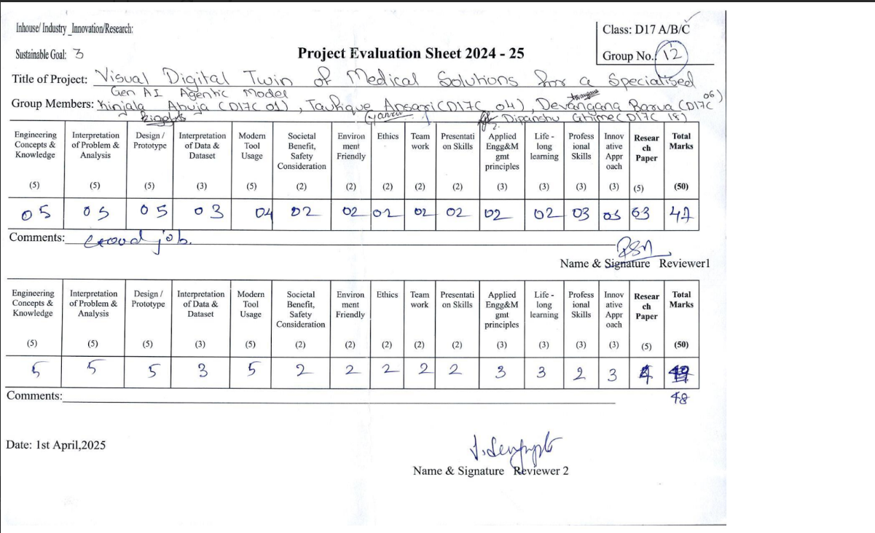**

**Review 1 sheet:**

